ENGAGING DEAF AND DISABLED YOUNG PEOPLE WITH HERITAGE

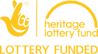
2018 TOOLKIT

Contents
Introduction 2
Why Engaging with Young, Deaf and Disabled People is Important 3
How to Use This Toolkit 3
Getting Started 4
Recruitment 4
Partnerships 5
Integration 6
Safeguarding 7
Re-creating Activities 7
Adapting Activities 8
Technology 10
Events 10
Ethics 11
Costs and Resources 12
Top Tips for Working with Young, Deaf and Disabled People 13
Where to go for Support 14
Find out More 15
Glossary of Terms 16
Cast Study 1: 18
‘Brave Poor Things: Reclaiming Bristol’s Disability History’ Film Workshops
Case Study 2: 20
‘Brave Poor Things: Reclaiming Bristol’s Disability History’ Games Workshops
Case Study 3: 21
‘The Blind School: Pioneering People and Places’ Film Workshops
Case Study 4: 22
‘The Blind School: Pioneering People and Places’ Sensory Story Making
Credits 24

Introduction

History of Place is a landmark project funded by the Heritage Lottery Fund that revealed the presence and place of disabled people in relation to the built environment. This history was told through the authentic voices of deaf and disabled people who founded, attended, visited and influenced building design and use from the Middle Ages to the present day.

The History of Place project has been delivered by the national programme Accentuate which creates ground breaking opportunities for deaf and disabled people to participate and lead within the cultural sector. It is based within the Creative Development Agency, Screen South.

We believe it is vital for deaf and disabled people to be at the heart of the project and for younger generations to be aware of their history. We have worked extensively with groups of young, deaf, disabled and non-disabled people to create a legacy which can be accessed by all. This includes a number of digital games, films, accessible exhibitions, creative workshops and events, which tell stories of deaf and disabled people through historic documents uncovered during archival research.

Over the last three years, the History of Place programme has been widely praised for our collaborative and accessible delivery techniques. As the programme is coming to an end, we feel that it is important to share our learning in the form of a simple ‘how- to’ guide for other organisations wanting to engage deaf and disabled young people. By collaborating with a diverse range of people, you can create opportunities which are richer and more accessible for individuals, allowing them to interact with your work in a more meaningful way. This is something we feel can be achieved through implementing our tips and recommendations when planning and delivering your activities.

Whilst this toolkit has been developed with a museum and heritage audience in mind, we are hopeful that these recommendations can be used across many different contexts.

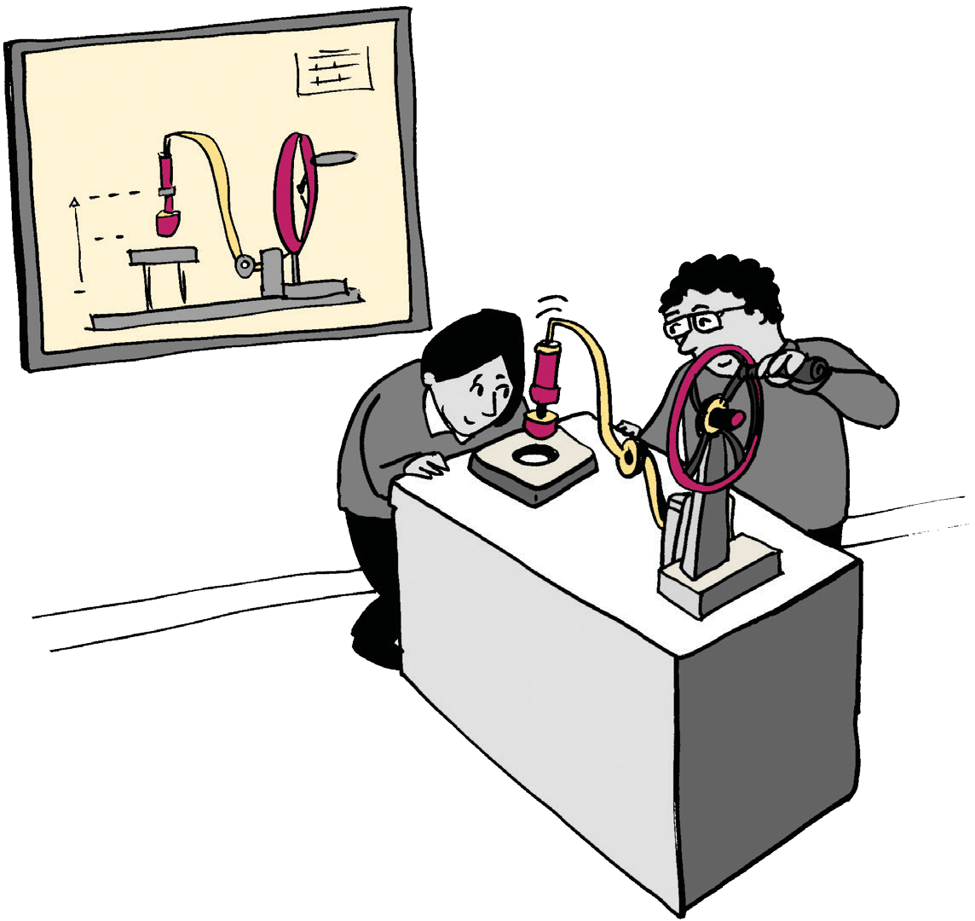

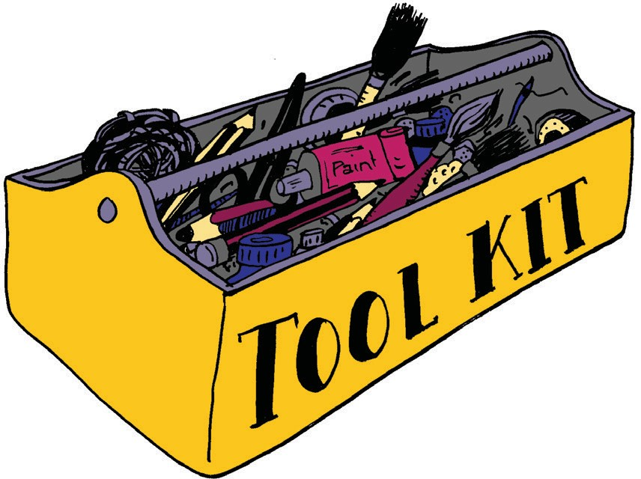
How to Use This Toolkit

This toolkit can either be used as a step-by-step process to follow when working with young, deaf and disabled people, or selected sections can be used to re-think how you can make certain activities more accessible. This toolkit also contains a useful glossary of terms, an index of where to go for further support and case studies to showcase the benefits of working with young, deaf and disabled audiences.

Why Engaging with Young, Deaf and Disabled People is Important

It’s estimated that today there are one billion disabled people in the world. Despite the rights of deaf and disabled people being protected under the Equality Act 2010, the history of deaf and disabled people continues to be overlooked, even though their stories are intrinsic to the environments we live in every day.

Deaf and disabled people include wheelchair users, people with mobility impairments, hearing impairments, vision impairments, Deaf people who use British Sign Language, people with learning disabilities, those experiencing mental ill health, neurodiversity, other non-visible impairments and chronic health conditions. They are also people who want and have a right to, visit exhibitions and enjoy culture.

Working with young people, defined in this toolkit as being under twenty-five, can enable your organisation to become a more engaging place by challenging perceptions and identifying new ways of working. This will help you to embed an access for all approach within your organisation, and ultimately broaden engagement and participation across all of your communities.

Getting Started

This section has been developed to provide advice and guidance to anyone interested in working with young, deaf and disabled people on an activity or project. It has been broken down into sections and provides practical advice which can be easily implemented.

Recruitment

Recruiting and working with deaf and disabled young people will enable them to shape how their heritage is displayed and interpreted and ultimately create closer connections to their stories. If you want to do this, we recommend following these simple guidelines:

- Give yourself time - finding the right people to be involved in a project is important. Ensure you factor enough time for advertising and recruitment into your planning. If possible, start thinking about how to recruit young people at least three months before you want to engage with them, and longer if possible.
- Identify and attend youth group sessions to build relationships with young people - bring an introductory, taster workshop activity so they can understand what you are offering and get excited by your work. You should identify someone in your organisation to lead on delivering this work. Ideally, this should be someone in a learning or engagement role.
- Once you’ve found people to work with, respond to their availability – understand which days work better for the majority of participants and how much time they are able to commit.
- Working with schools can bring challenges - staffing, schedules and resources are usually tight and they often need more time to respond to offers of engagement.
In order to develop a good working relationship, work with schools who have the infrastructure, safeguarding staff support and know the young people well. Schools tend to have tightly controlled budgets, so ensure you are able to cover the costs of being involved, such as transport costs, if you are bringing pupils to your organisation.

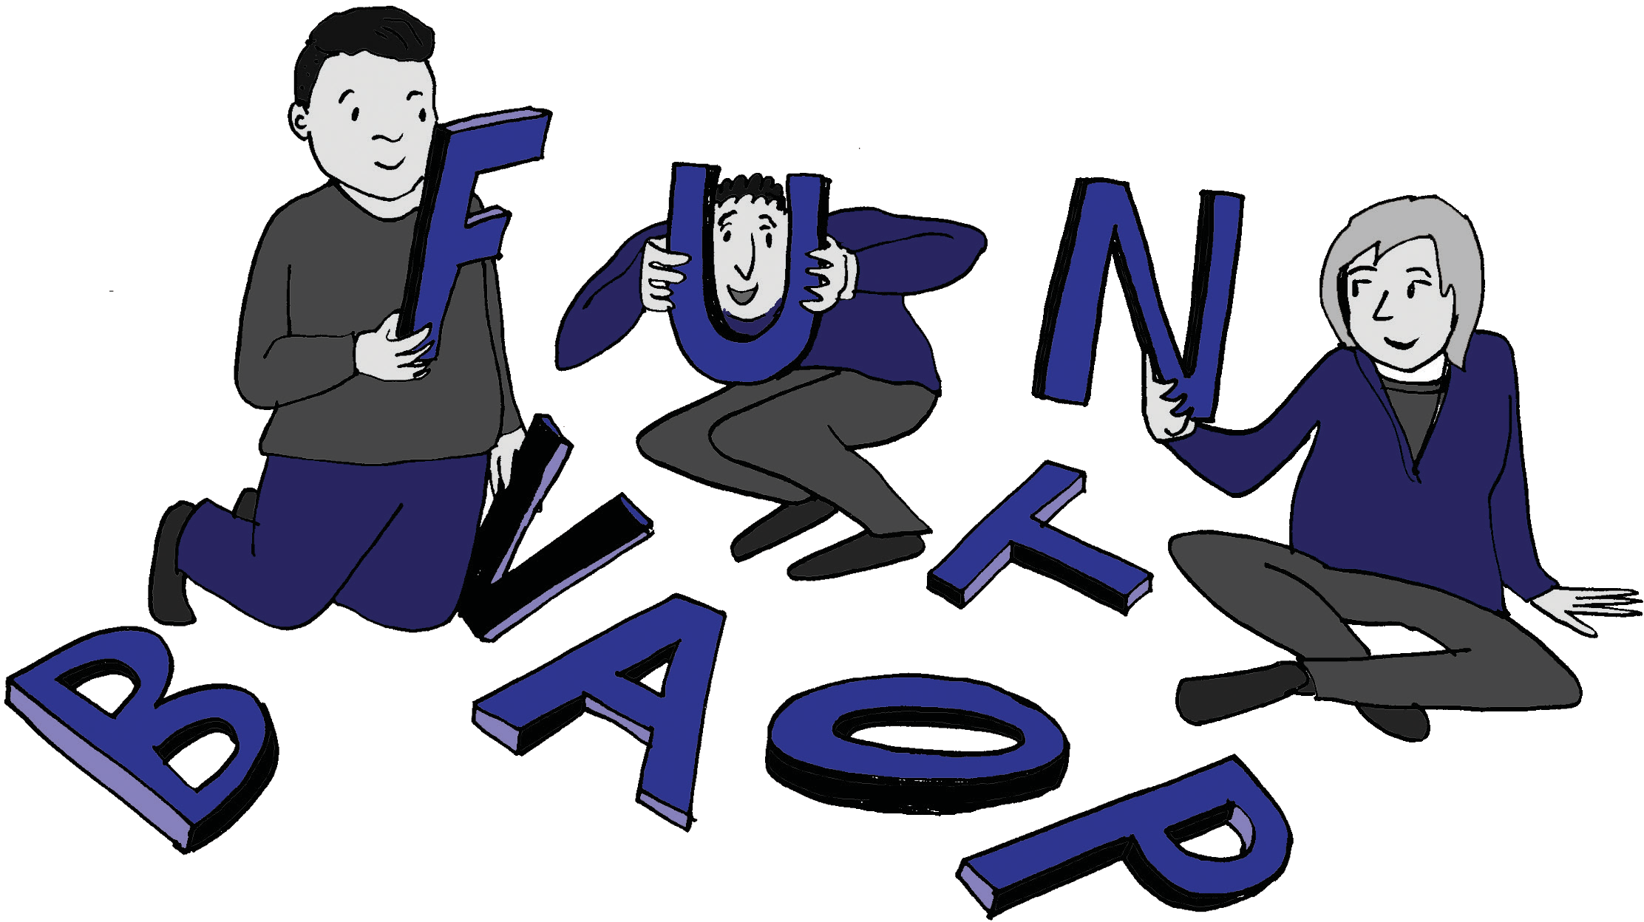

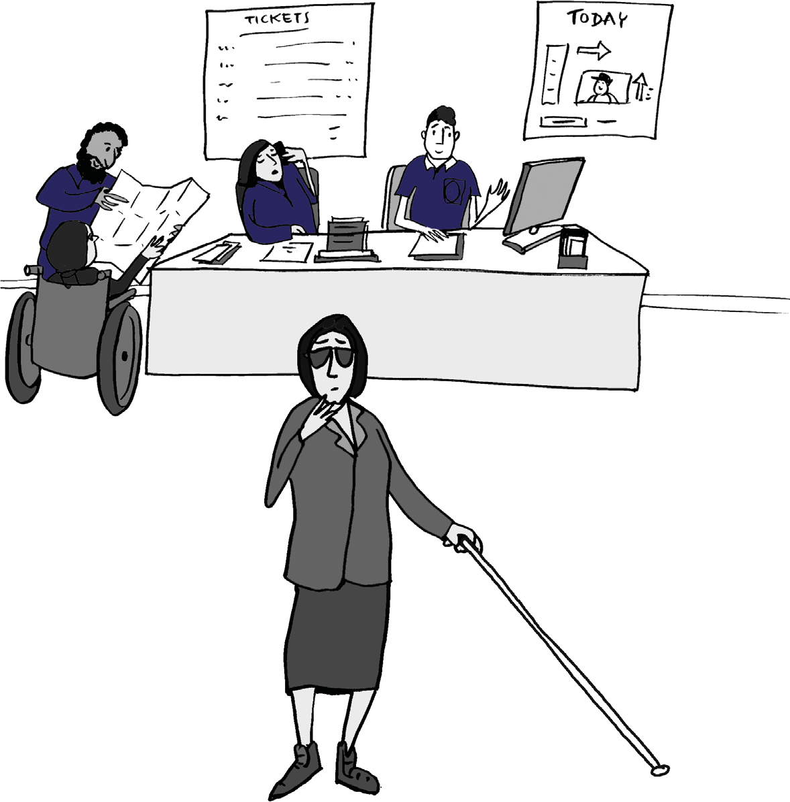
  - Ask in advance for people’s access requirements and be sensitive
in doing this - think about how you are able to respond to their
requirements and build in budget and extra time to meet access needs.
  - Undertake disability equality training for your team and any partners
you may work with. This will give staff and volunteers the skills and confidence to support deaf and disabled people and will ensure that the people you are engaging with have a positive experience or your activity and organisation.
Accentuate can support this training or can advise on other organisations which also provide these services.

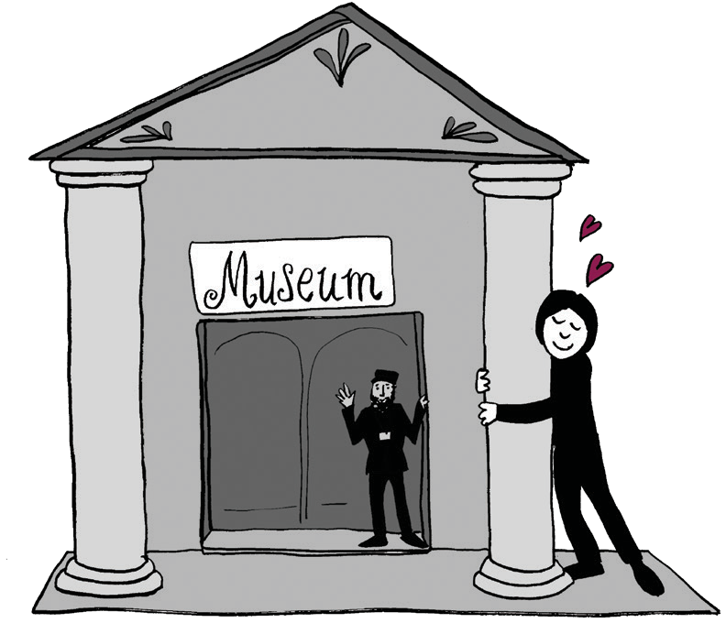
Partnerships

Partnerships between established organisations can help to build trust with potential participants. For example, knowing an activity or programme is connected to a well known organisation or venue might encourage more people to get involved and add value to your offer. These partnerships may also be able to provide you with a public, accessible venue to run activities if you do not have your own, or/and a means of recruiting participants.

When identifying organisations to work in partnership with, it is important to ensure that you share the same outlook, both are equally as
committed to the partnership, and that clear lines of communication and responsibility are established.
When partnerships work well, they can transform the audiences and reach of your project.

Getting Started (contd.)

How we did it:

The History of Place project worked with WECIL in Bristol, a disabled person led support group, to recruit young people for our activities. We successfully recruited via their networks, and used posters, call outs with members and attended youth group evenings to discuss the project face to face with young people. WECIL supported this by brokering relationships and identifying the young people that might benefit from being involved and who would enjoy the activities. Having the partnership with WECIL meant that the young people, and parents/guardians, trusted the project as they knew WECIL understood young people’s needs and had their best interests in mind. The relationship they share with most parents/guardians has been built over a number of years. This is important, especially when working with deaf and disabled young people.

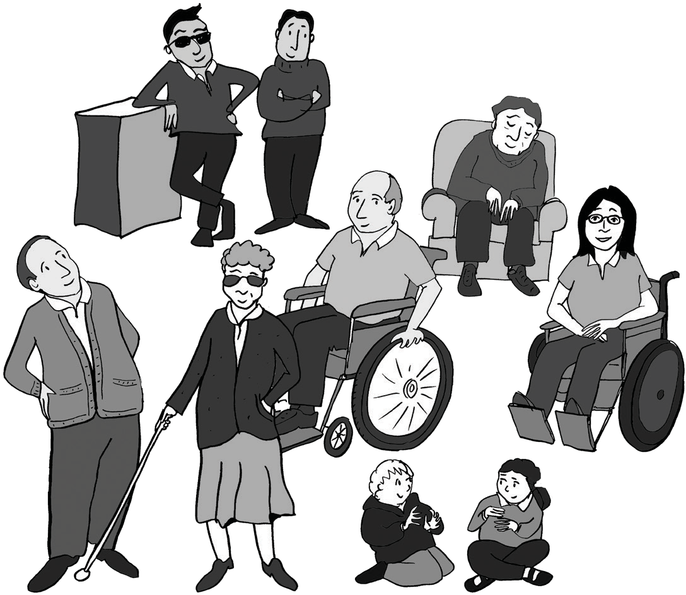
Integration

When working with the history of marginalised and minority groups it is important for representatives of that community to reclaim the
narrative and have a say in how this is presented. Through involving both disabled and non-disabled young people in your activities, you are
able to encourage the exploration of lived experience for disabled people and facilitate learning for non-disabled participants. Taking this further, members of these marginalised groups are then better able to understand the importance of their story for wider society.

Safeguarding

Organisations should have an up-to date and robust safeguarding policy or statement in place, you should not be working with young, deaf and disabled people if you do not have one. This is intended to protect the young people you work with, keeping them safe and provide clear guidance on how to respond to any concerns. Safeguarding awareness training should be provided to all people involved in your project or activity. The NSPCC provide helpful support and guidance about this on their website.

In addition to safeguarding policies, we recommend that any adult working with young, deaf and disabled people should also provide a current, enhanced Disclosure and Barring Service (DBS) check. This should include staff, volunteers and facilitators.

Re-creating Activities

When recreating activities that were practiced in the past, it is important to be mindful not to recreate those which wouldn’t be acceptable or ethical today.

A practical example of this could be delivering craft activities which were historically undertaken by institutions working with disabled people that are now considered to be inappropriate ways to ‘keep people busy’. If you consider recreating a craft activity, such as basket weaving or embroidery, it is important that you do not mis-represent the past and that the complexities of issues associated with this work are explored. It would not be possible for disabled and non-disabled young people to learn the really intricate skills required for these activities in just a few basic workshops and it would be inaccurate
to re-enforce the stereotype that this activity was low skilled and recreational.

Top tip:
Having deaf and disabled artists and workshop leaders delivering activities, particularly when working with
non-disabled participants improves understanding!

Getting Started (contd.)

Adapting Activities

We understand that you might want to adapt some of your existing activities so they are accessible for all. We suggest you:

- Use artistic, creative activities which allow participants to focus on reflection instead of group discussions which might be overwhelming for some. For example, creative activities such as design, music, film and craft encourage critical thinking and provide the opportunity for participants to express themselves non-verbally.
- Provide a range of craft materials and have support on hand to use these effectively.

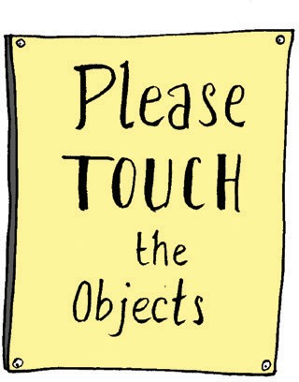
Top Tip:

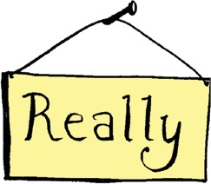
Tactile materials can be more engaging for those with sensory impairments.

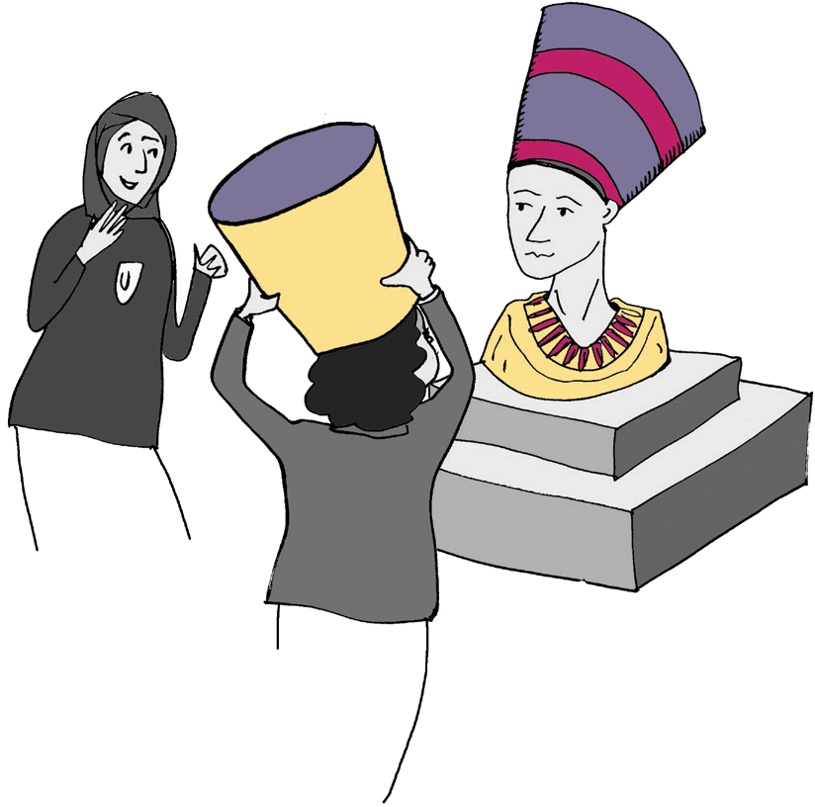
- Allow for flexibility and movement in the space you’re working in. For example, when working with young people with learning disabilities, autism, ADHD or similar, a presentation or diagram might not be
the best way to understand, but physical expression might bring the subject alive.
- A Personal Assistant might be required for some participants to fully engage. Ensure you consider the workshop facilitators to participant ratio, keeping in mind that there is enough support available, but not so there are more adults than young people. In doing this it is also important to ensure that you find ways for the young people speak for themselves. Don’t rely on their assistant to tell you what they are thinking.
- Make activities playful and fun. Bringing stories alive with a humorous approach helps to bridge the gap between the historical material and generating your creative outputs.

Try this idea:

Create a one-line story with each person adding a line. Start with ‘once there was a lady called...’ and then move to the next person and ask them to continue the story by adding one line. It is much easier to engage with participants in this way than asking for an individually produced script.

- Identify what the young people are interested in and encourage this interest as a means of exploring the past, framing it to sustain their curiosity.

How we did this:

One of the young people involved in our research group was particularly interested in acting, so we encouraged this by asking how they wanted to take this forward.
Identifying that the project needed people to voice the audio description for the project exhibitions and characters in a digital game, the young person volunteered to do this for us!

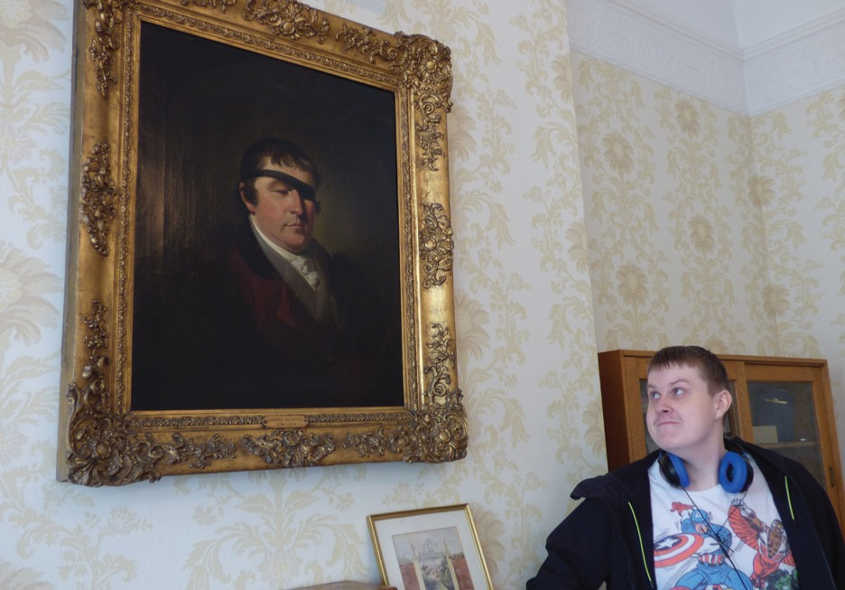

Young disabled performer gaining inspiration from the portrait of school founder Edward Rushton in preparation for his portrayal of him in a film at the Royal School for the Blind, Liverpool.
- Ask the participants for their opinions and capture them in a creative way. For example, you might ask them to design their dream version of an accessible exhibition, and use this to encourage discussion and comparison against real-world examples.
- Some participants may use a communication aid, if this is the case then make sure you provide
an outline of the activity and any potential questions which will be explored to these people in advance. Communication aid users may need more time in workshops to respond to questions and creative ideas so ensure your workshop
is structured well enough to facilitate this.

Getting Started (contd.)

Technology

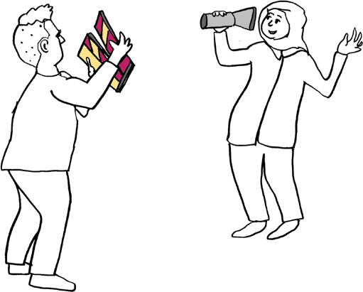
Technology can be a useful tool in engaging with young, disabled people. By using tablets and audio recording devices, you can create more interesting sounds, e.g. an echo, or original music and layered soundscapes. Tablets provide young people with the opportunity to act independently and make their own decisions. If tablets are not available, a small handheld video camera is an alternative and will still enable young people to record their own experiences. These can be purchased relatively inexpensively from approximately £30 each.

Once you have created film content, editing the footage together in the workshop can also be a useful device. Even a quick edit of the work achieved in your sessions, regardless of quality, can be a great way to show participatants what they have achieved. This can then be followed up by a more professional edit of the work, and shared with the participants electronically, either via a password protected online link for example from Vimeo, or an open view platform such as YouTube etc.

If utilising technology, it is important to ensure that the workshop leader is confident with the equipment being used and that there are enough workshop facilitators available to show the participants individually if needed.

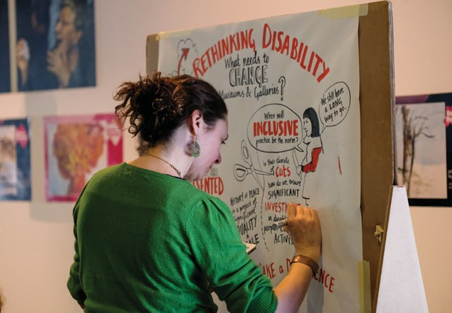
Events

Involving young disabled people at different milestones throughout a project provides more genuine engagement and ensures their input is felt across your activities. Events are an excellent way to do this.

Ensure the contribution of young, deaf and disabled people is both recognised and celebrated. involving them with or inviting them to events will enable them to interact with stakeholders, advocate for your work and ensure that their
voices are heard. You can also create a visual record of these events, using visual minutes to illustrate discussions. To find out more about visual minutes please refer to the ‘Glossary’.

Visual Minutes being created in real time at History
of Place’s ‘Rethinking Disability’ Symposium

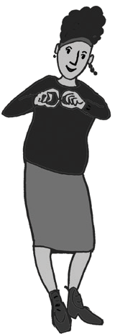
It is essential to take into account the participants requirements in running any event. Do they feel confident in front of an audience? Would they prefer to be present when their work
is shown to an audience? What kind of events do they feel interested and confident in attending? Consider the needs, opinions and access requirements of your young people and adapt the event to suit, for example providing palantypists and BSLI.

How we did this:

During the History of Place project, we wanted the work created in the digital game making workshops to have another opportunity to be shared. The young people who had created the characters for the game came together for a rehearsal and produced a short scene for the private view event of our exhibition at M Shed in Bristol. We also recruited a professional actress, who identified as disabled, to perform alongside the young people. The actress was the central character, which meant she could hold the scene and allow the participants to improvise and feel safe in the performance.
We asked one young person, who was not comfortable being on stage in front of people, to create the music instead of performing. The activity enabled the young people to have ownership of the performance, using their ideas and creativity but
it was balanced with the professional actress taking the lead meaning there was less pressure on the young people.

Ethics
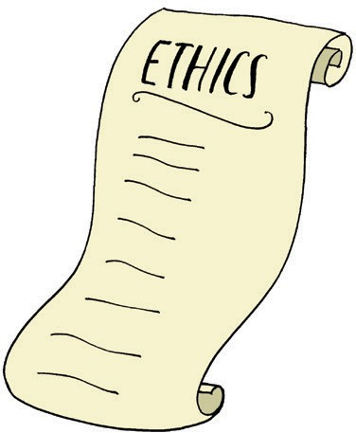
A key element in working with young people is consent. Extra care should be taken when asking for consent from young people, whether it is using their image, their stories or their ideas. A full understanding of the potential uses of these materials should be reached and support workers, parents and guardians involved if necessary.
You should have safeguarding policy and procedures in place before working with young, deaf and disabled people. Details on advice on safeguarding are available in the ‘Safeguarding’ section of this toolkit.

You should continue to consult with disabled people at every stage when creating something which they are involved in. Their involvement and consent does not give you the right to tell their stories in your
own way so it is important to continue engaging with them regularly.

Generally, identifiable images should not be shared on social media and should be restricted to the organisations’ archive and certain publications, such as the annual report or evaluation report. Ensure you never
exploit disabled people in order to benefit an organisation or project.

Costs and Resources

Delivering creative, engaging activities which are accessible for young, deaf and disabled people will cost more money, but that should not be an excuse not to do it. Make sure you consider the costs of increased accessibility in advance and if you are applying to funders make sure you have included these costs in your application. The following will help you consider some of the costs that you may want to include:

Item | Breakdown of Estimated Costs* | Estimated Total Costs*
Access requirements | BSL interpreter - £350 per day, Audio Describer - £300 per day, lip-speaker  - £350 per day, accessible versions of printed materials (large print, Braille, Easy Read) - £50 per document per accessible method, personal assistant/support staff -  £300 per person per day, palantypists (for events) - £350 per day, enhanced DBS checks for staff/volunteers - £44 each | Dependent on the access requirements of the participants
Technology | Tablets - £300 per device, sound recording devices (Tascam) - £80 per device, camera - £500, hard drive - £100, speakers - £50 per device, hand-held video recorders - £30 per device | Approximately £1500 (this equipment can be reused)
Materials | Craft materials and equipment - various, tactile objects – various, sensory smell pots from £20-£50 | Approximately £200 per workshop
Creative workshop leaders | For example, artists, actors, film makers, creative writers -  £350 per person per day | £350 per workshop
Travel expenses and refreshments | Consider some participants will need taxi’s - £30 per person, refreshments - £100 per day | Dependent on the venue location and access requirements of the participants
Venue | Varies depending on type of venue, location, number and size of rooms | Approximately £400 per day
Other | Visual minute takers - £400 per artist  per day, marketing and printing of posters (and audio posters) to recruit  participants - £500, | £800 per day

*please note these costs are indicative.

Expect some costs to be higher as you will need to book increased support staff and may need a venue with a larger room (for flexibility), a breakout room (to provide a relaxed space) and one that is fully accessible (entrances, lifts, toilets, parking). Understand
that the access needs of young people may mean you need to book a more expensive venue for example, a city centre venue with accessible parking for participants.

Additionally, some access workers, such as BSLI, can only work for thirty minutes before taking a break, therefore you will need to book a sufficient number of interpreters
to cover the participants’ requirements and to allow for comfort breaks.

Top Tips for Working with Young, Deaf and Disabled People
Implementing these quick wins will help you to create new, or adapt existing activities to reach new audiences and work with young, deaf and disabled people. Our recommendations are outlined below:
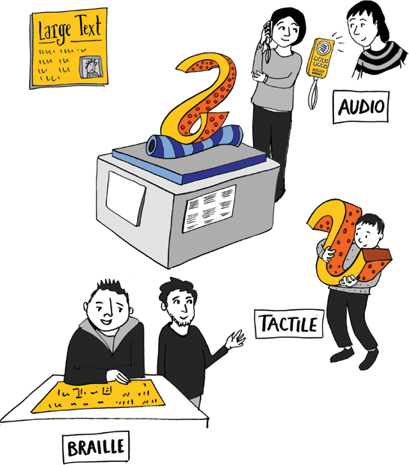
  - Most importantly, do it! Engaging deaf and disabled young people brings creativity, opens up audiences and adds different perspectives through alternative lived experiences.
  - Consult with young people and involve them in every step of your project or activity, including during the decision making stage.
  - Use a range of materials and methods in your workshops. Tactile materials, audio, costumes and smell pots can all help to bring history alive for young people and can help participants with sensory impairments to engage with the material.
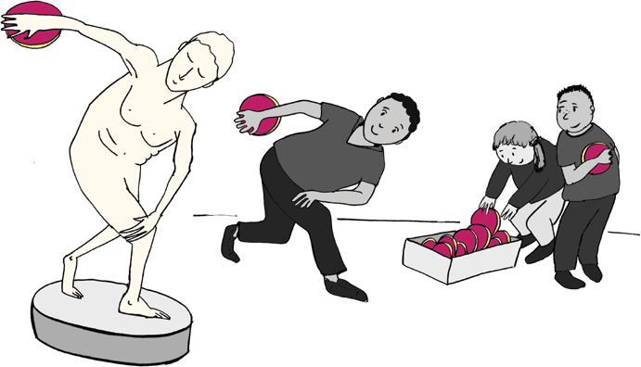
- Make it fun! This helps to make any activity more engaging, and also breaks down barriers for participants.
- Ask for access requirements in advance and book access staff and materials in advance.
- Participate in disability equality training to give yourself the confidence and knowledge to effectively engage deaf and disabled young people. It is essential you approach
working with deaf and disabled people from a social model perspective and have this at the heart of everything you do.
- Be mindful when re-creating historic activities. These could reflect practice which is no longer perceived as acceptable or is more complex to understand.

Where to go for Support

The following can provide support and materials to help you organise and deliver accessible activities and events for young people:

- Accentuate, a range of toolkits for working with deaf and disabled people www.accentuateuk.org/toolkits
- Big Lottery working with young people guides, advice on working with young people www.biglotteryfund.org.uk/research/children-young-people-
and-families/working-with-young-people
- British Deaf Association, for support and information https://bda.org.uk/
- Changing Places – best practice and advice on creating accessible toilets www.changing-places.org/
- Equalities Act 2010 guidance https://www.citizensadvice.org.uk/Documents/Advice%20 booklets/equlity-act-2010-overview.pdf
- Heritage Lottery Fund, for support and advice www.hlf.org.uk/running-your-project
- Mencap Liverpool, for producing Easy Read documents www.mencapliverpool.org.uk/want-help/easy-read-services/
- NRCDP, for booking BSLI, lip-speakers, palantypists and audio describers www.nrcpd.org.uk/
- NSPCC – examples of and advice on safeguarding policies and procedures for deaf and disabled young people
https://learning.nspcc.org.uk/safeguarding-child-protection/ddeaf-and-disabled-children/
- RNIB, for Braille, raised letters and large print document production and objects www.rnib.org.uk/
- Social Model of Disability
www.scope.org.uk/about-us/our-brand/social-model-of-disability
- Visual Minutes www.morethanminutes.co.uk/
- VocalEyes, resources relating to working with blind and VI people https://vocaleyes.co.uk/services/resources/
- Young Archaeologists Club handbook, tips on engaging young people with heritage https://www.yac-uk.org/yac-handbook

Find out More

If you are interested in the recommendations in this toolkit, and would like to find out more about the History of Place project, head over to:

- History of Place, http://historyof.place/
- Screen South, http://www.screensouth.org/
- Accentuate http://accentuateuk.org
- Museum of Liverpool, http://www.liverpoolmuseums.org.uk/mol/
- M-Shed, https://www.bristolmuseums.org.uk/m-shed
- V&A, www.vam.ac.uk
- 360 degree videos of the exhibitions, www.historyof.place/multimedia/
- The Story of Helen digital game www.historyof.place/thestoryofhelen
- Dear Drennan digital game www.historyof.place/deardrennan
- Liverpool digital game www.historyof.place/multimedia
- Bristol digital game www.historyof.place/multimedia

Glossary of Terms

Some of the terms in this toolkit might be new to you so we have put together this helpful glossary to explain some of the terminology:

- Audio description: an additional narration track intended primarily for blind and visually impaired consumers of visual media. An audio description consists of a narrator describing what is happening
on the screen or stage during natural pauses in the audio, and sometimes during dialogue if deemed necessary. It is also used to describe visual material such as photographs and paintings.

- Blind/visually impaired (VI): visually impaired means someone has a reduction in their vision which is not altered by the
use of glasses or contact lenses. A blind person may have some vision, see shadow and light, or have no vision.

- Braille: Braille is a tactile writing system used by some people who are visually impaired. It is traditionally written with embossed paper. Braille users can read computer screens and other electronic supports using refreshable braille displays.

- BSL/British Sign Language: is the first, or preferred, signed language of some Deaf people.

- BSLI/British Sign Language Interpreters: people who relay conversation between Deaf British Sign Language users and hearing people. The interpreter will translate BSL into spoken English and spoken English into BSL for easy communication between both parties.

- Contrast print: contrast print describes the high contrast between the text and backgrounds (i.e. black and off-white) making the text more visible to people with low vision.

- D/deaf: describes people who are Deaf (British Sign Language users) and deaf (who are hard of hearing but who have English as their first language and may lip read and/or use hearing aids).

- Easy Read: Easy Read is a method of presenting written English to make it easier to understand for people with learning disabilities. Typically, Easy Read uses sentences that should be no more than ten to fifteen words and each sentence should have just one idea and one verb.

- Large print: refers to the formatting of text in which the font, and sometimes the medium, are considerably larger than usual, to assist people who have poor vision.

- Orientation (within audio description): provides key pieces of information to the listener that orientates them within the space such as where cases
are situated, which direction to face and how to move around the space.

- Relaxed spaces: the creation of a space that is comfortable for everyone, especially people who would benefit from a more informal experience.

- Social model: the social model of disability identifies systemic barriers, negative attitudes and exclusion by society (purposely or inadvertently) that mean society is the main factor in disabling people, not the impairments they may have.

- Visual minutes: visual minutes are a live, illustrated record of conferences, events or meetings. The minutes unfold during the event and the information is brought to life with illustrations and colour. Visual minuting, or graphic recording, pulls out the key themes and messages making the information digestible.

Case Studies

Over the period of three years, the History of Place project worked with a number of partners to engage young, deaf and disabled people in the project thorugh a variety of means. These included:

- Creating a film for the ‘Brave Poor Things: Reclaiming Bristol’s Disability History’ exhibition at M Shed, Bristol.
- Creating a digital game for the ‘Brave Poor Things: Reclaiming Bristol’s Disability History’ exhibition at M Shed, Bristol.
- Developing a full length film and a shorter edited film for the ‘The Blind School: Pioneering People and Places’ exhibition at the Museum of Liverpool.
- Creating a sensory story to share the history of the Royal School for the Blind, Liverpool.

This section contains case studies of key learning taken from developing these outputs associated with the History of Place project.

Case Study 1:
‘Brave Poor Things: Reclaiming Bristol’s Disability History’ Film Workshops

Who was involved: A group of local young, disabled and non-disabled people aged 13- 18 (a varied group attended over the period of two weeks with some participants involved for the whole period and some for odd days). This involved input form
a Director, Producer, project coordinator, Managing Director of Screen South, a volunteer film intern, a support worker, two BSL interpreters and a creative writer.

What we did: We held two weeks of film making workshops to create the content for the film; ‘Our Guild.’ The workshops included exploring original archive material and creating responses to the historic material through art, performance and script writing. The participants learnt film making skills such as operating the sound and
camera equipment. They devised and shot scenes, researched background material and responded to ‘The Guild’ building itself and the issues relating to the subject matter.

Impact and lessons learned: A key element of the film making workshops was the use of alternative, creative methods, integrated with access. For example, the creative writing workshop was led by a trained drama therapist. This allowed for a different approach to film making and enabled the participants to connect to the historic material in an alternative way. Another example was when we discussed the accessibility of ‘The Guild’ building and
compared it to the accessibility of buildings today. This was difficult for some of the participants to contextualise. We responded by runing a workshop where we created our own accessible buildings from craft materials. We then shared and discussed these as a group and the participants engaged with the benefits and pitfalls of ‘universal design’ and the ethics surrounding it. This was a good way to discuss the themes that straight conversation couldn’t achieve.

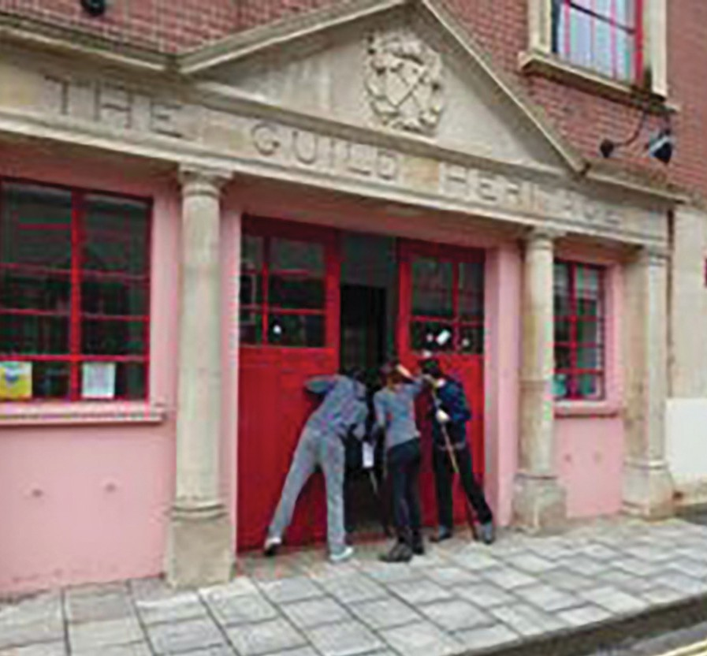
Film workshop participants peer through the door of The Guild Heritage building in Bristol
When one participant, who used a communication aid, joined the workshops we adapted how we created ideas and presented them. This flexibility and creativity benefitted the whole group, giving us more time to work on and share ideas in a group. These ideas were then captured on film and in note form.

A key lesson from these workshops was the importance of having enough people, time and resources available to allow for flexibility and creativity. We also found it useful to have alternative activities and versions of activities ready to enable a flexible approach with
participants. Some people wanted to write, some wanted to express their thoughts in conversation and some preferred using visual aids.

“We all joined the project in order to expand our understanding, and learn about what had happened in the past, and why we have a huge understanding and respect towards those with disabilities. This is one of the reasons we had all became friends. We all wanted to know more. With this project and the time, we have spent with the group we were able to learn about the different types of people that existed in history, and able to learn that maybe it isn’t a disability, maybe it’s something that is unique, something that make you different from others. So what we’re going to take from this is a life time of experience that we will use in the future.
We are all glad to be a part of this group and we’re glad that we took the time out of our lives to learn about The Guild of the Brave Poor Things. We hope that all those people who watch the film take something important from it, and learn from the experiences of those who lived in the past.”

Film making workshop participants

Case Studies

Case Study 2:
‘Brave Poor Things: Reclaiming Bristol’s Disability History’ Games Workshops

Who was involved: Fifteen local young people, both disabled and non-disabled, a games facilitator, project coordinator and a sound designer to support the recording of the sound assets.

What we did: We ran a series of workshops which explored the historic archive material and research produced by volunteers. This was used to devise the ideas, structure and narrative of the game which was inspired by ‘The Guild of the Brave Poor Things’. Participants played games, shared stories and created assets which were used to create the digital game.

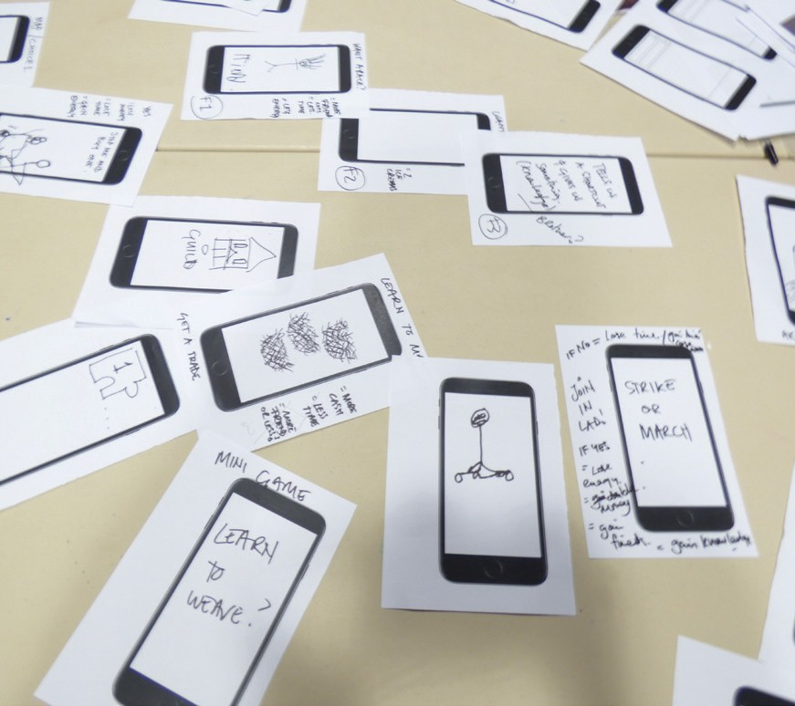
Impact and lessons learned: During the workshops the participants were able to have fun with the historical information through game play. Playing physical games like ‘snake’ in the room, and vocal games, set the tone for the workshops to be fun.
We were able to feed in the historical facts to these games when trust and a playful connection had been established. This meant the outcome of a game was collectively understood, with the facts integrated.

Participants sketched the game narrative onto mobile phone screens to imagine what the game world look like
Making elements ‘live’ worked well for this group. One example of this was when we were imagining moving across locations and the challenges that would be faced within the game. To explore this, we drew it out in chalk on the floor and then physically moved around. This enabled the young people to visualise the abstract ideas and also was good for those with dyspraxia, learning disabilities, autism
and ADHD to move around within the ideas.

Top Tip:

In working with young, deaf and disabled people to build a digital game for inclusion in a History of Place exhibition, we worked with a digital development team. We found it was really important that some of the digital developers were present for these creative workshops. This enabled them to listen to the ideas of the young people, feedback on what is possible, and ensure that the content created by the young people is useable in a digital format.

Case Study 3:
‘The Blind School: Pioneering People and Places’ Film Workshops

Who was involved: The workshops took place as part of a summer camp for young people, aged 11-17, who are blind or visually impaired and was based at St Vincent’s School for Sensory Impairment (some of the young people involved attended the school and others attended different schools and colleges). The workshops involved two creative filmmakers, the project coordinator, Managing Director of Screen South, a scriptwriter, an audio describer and members of the volunteer research group.

What we did: Created two films. One about the history of the Royal School for the Blind, Liverpool, using archive material to inspire the content, and one which was a shorter version for inclusion in the Museum of Liverpool exhibition which focussed on the theme ‘attitudes’. The workshops were structured to provide participants with a complete experience of making a community film.

The team participated in ‘visual impairment awareness’ training at the school prior to the workshops. This was important because it gave everyone the confidence to work with the young people, act as a sighted guide and understand how the young people moved around the school. Participants learnt how to use cameras, microphones, identify locations for filming, set up a shot, conduct interviews, integrate historic archive material into film media, edit and write a script. We also used a variety of sensory materials to bring stories
of the Royal School for the Blind, Liverpool to life for the young people. This included using sounds, objects, scent pots and large print versions of photographs and archive documents. We interpreted many of the historical documents, recreating the costumes people in photographs were wearing so that the participants could feel what they looked like.

Sharing the facts, myths and legends of the school, the young people responded from their perspective and explored the questions:
- What would they have done in that situation?
- How would they have felt?
- Could they share an example of when something this similar may have happened to them and how did the react?

This meant participants shared personal, sometimes upsetting, experiences. As a result, we created a safe space, intentionally keeping the group small and doing a tactile craft activity during conversations. The participants led on developing the narrative and content for these films, selecting what to include and identifying the places they felt comfortable filming. We respected and supported their decisions.

Case Studies

Case Study 3 (contd.):

Impact/lessons learnt: We found particular success when exploring the content related to deaf and disabled people, the former students, founders of the school and the writers of the documents within the archives. Sharing what we know of those individuals and how they experienced life was illuminating, providing avenues for our young people to be really creative. For example, a photograph of a former student with his pet cockerel was reimagined by them to be a guide cockerel who helped him to be independent!

We understood that the young people involved saw the workshops as important because they created a film that helped viewers understand what life was like for disabled people, rather than just taking part for fun. One of the most enjoyable workshops was when the young people conducted an oral history interview with a former student and
a former teacher. They found it interesting to compare their experiences as blind and visually impaired people, attitudes they’d experienced and their aspirations. Engaging the young people in historic information in the form of memories worked well and these rich interactions came across in the film. Having people with lived experience of being a disabled person interviewing was much more authentic and the exchange more open.

“Through the film that we’re making, more people might then feel able to ask disabled people if they need help in getting
somewhere or finding whatever it is, without being embarrassed or uncomfortable.”
Film workshop participant

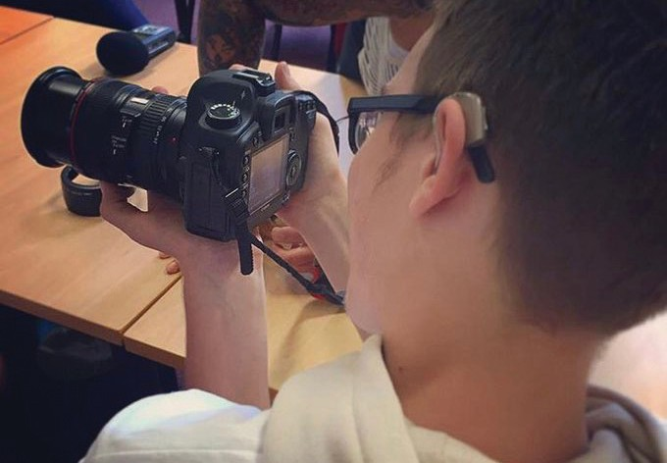
A young person learns how to use a camera in the film workshops

Case Study 4:
‘The Blind School: Pioneering People and Places’ Sensory Story Making

Who was involved: A sensory artist, sound artist, project coordinator and students from Royal School for the Blind, Liverpool (aged from 3-19).

What we did: Led a series of workshops with students from different classes-from the nursery toddlers to the post-19 class to create and tell stories associated with the Royal School for the Blind, Liverpool. The students who attend the school today have a visual impairment plus other impairments which include learning, sensory and physical. We planned the workshops to be as flexible and inclusive as possible so that everyone could take part.

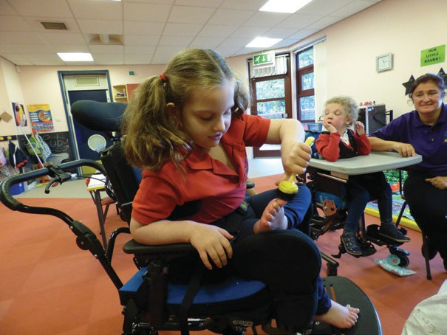
Participant uses an object to tickle her feet.
Having previously identified four stories that were important in the history of the school, we aimed to develop these with
the students. They were the life of one of the founders Edward Rushton’s ‘sea journey’, royal visits, tunnels and seaside visits and traditional crafts which took place at the school.

Working with each class to tell a story about the history of their school and a sound artist to create a soundscape for the story, we used objects, scents, costumes and sensory items (smells and a fan). Using these sessions as a way to work out what excited the young people, what they enjoyed touching and the sounds they responded to, we found out that the popular objects included a rope, scrubbing brushes, material which floated for the waves, a thunder clapper, shells, salt smells, a bag of coins, various materials, a crown and jewels.

We were able to identify new things to include in these stories by how the students responded. For example, one student was deaf and rather than use the barrel to feel the wood he put his head inside to feel the vibrations it made. In addition, we learnt that their yearly trip to the seaside is lead by a Police motorbike with the sirens and lights on and that this was particularly enjoyable for the students. Knowing this, we added this extra detail into the final story by including sirens on the soundscape and a torch to use as a flashing light whilst the lights in the room were switched off.

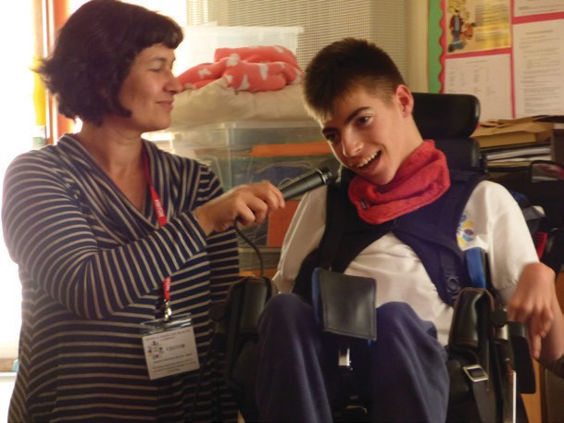
Participant makes sounds to contribute to the story soundscape.
Impact and lessons learned: Scent pots, making sounds and sing-a-longs were the most popular elements of this activity. Understanding this, we created ‘activity vests’ for the students who preferred to explore in their own time. The vests have the objects attached so that they can feel, make sounds and explore
textures themselves whilst the other students are handling objects.

Whist the sensory approach may seem to be more suited to younger children, we learnt that it also worked well with the post-19 group. This group expressed that they struggled to find adult themed stories that could be told in an accessible way and they enjoyed learning about the history of their school in such a creative way. Using these techniques, we were also successful in engaging young people who usually chose to work alone.

Credits

Thank you! By reading this toolkit you have made the first step in making your exhibitions, museums and spaces more accessible for all.

Museums and heritage organisations hold an important societal role in capturing, creating and interpreting the world, and this guide will help you take responsibility to make positive changes to ensure that the history of everyone is represented.

We would love to know how you use this guide or how you have made your activities accessible and worked with deaf and disabled young people. Let us know by tweeting us at: @H_O_P

Feel free to share this toolkit with other organisations you think might find this useful (museum or non-museum!). If you would like a copy of the guide
in an alternative format, please get in touch with us at Screen South:
Accentuate History of Place Screen South
The Wedge
75-81 Tontine Street Folkestone
CT20 1JR
Tel: 01303 259777

Find out more about the History of Place project and visit historyof.place

With special thanks to our contributors, Esther Fox, Grace Swordy, Kerry Massheder-Rigby, Katie Ann Smith, Paul Homer, Jo Nolan, Charlotte Kingston, Olivia Horsfall-Turner, Karen MacDonald, Catherine Johnson, Kay Jones and all the volunteers, workshop participants and organisations who contributed their thoughts and experiences over the course of the History of Place project.

Additional thanks is given to the Heritage Lottery Fund for their support and advice. Without this, History of Place would not have happened.

Illustrations by Beatrice Baumgartner-Cohen www.cohenbaum.com

This toolkit was funded by the Heritage Lottery Fund and our sponsors. It was developed and delivered by Accentuate History of Place, part of Screen South

