ACCESSIBLE EXHIBITIONS

FOR ALL:
A GUIDE TO CO-DESIGNING EXHIBITIONS WITH DISABLED PEOPLE

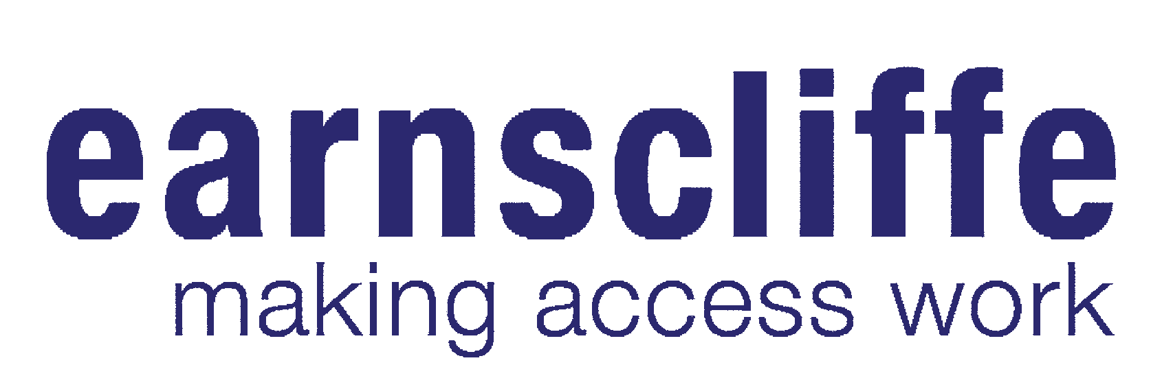
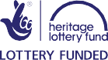
2018 TOOLKIT

Contents
Introduction 2
Why Creating Accessible Exhibitions is Important 2
How to Use This Toolkit 3
Getting Started 4
Creating Content 4
Object and Image Selection 5
Curating the Content 5
Safeguarding 6
Accessible Design 6
Partnerships 9
Events 10
Ethics 12
Funding and Planning 14
Realistically Planning Your Costs 15
Exhibition and Event Top Tips 16
Where to go for Support 17
Find out More 17
Impact 18
Glossary of Terms 21
Cast Study 1: 22
‘Brave Poor Things:Reclaiming Bristol’s Disability History’ Audio Tour, M Shed, Bristol
Case Study 2: 23
Flag Making in Bristol: Interpreting the Archives
Case Study 3: 24
‘The Blind School: Pioneering People and Places’ Exhibition, Museum of Liverpool
Case Study 4: 26
‘Without Walls: Disability and Innovation in Building Design’ Display at the Victoria and Albert Museum, London
Credits 28

Introduction

History of Place is a landmark project funded by the Heritage Lottery Fund that revealed the presence and place of disabled people in relation to the built environment, told through the authentic voices of deaf and disabled people who founded, attended, visited and influenced building design and use from the Middle Ages to the present day.

The History of Place project has been delivered by the national programme Accentuate which creates ground breaking opportunities for deaf and disabled people to participate and lead within the cultural sector. It is based within the Creative Development Agency, Screen South.

Over the last three years, the History of Place programme has been widely praised for our collaborative and accessible delivery techniques. In particular, we have produced three nationally significant, accessible exhibitions with museum partners: the Victoria and Albert Museum, London, the Museum of Liverpool and M Shed in Bristol.

As the programme is coming to an end, we are sharing our learning in the form of a simple ‘how-to’ guide for other organisations wanting to produce accessible exhibitions. By collaborating with a diverse range of people, you can create experiences which are richer and more accessible for individuals, allowing them to engage with your work in a more meaningful way. We believe this can be achieved through implementing our tips and recommendations in your planning and delivery of your displays, and exhibitions.

Whilst this toolkit has been developed with a museum and heritage setting in mind, we are hopeful that these recommendations can be used across many different contexts.

Why Creating Accessible Exhibitions is Important

It is estimated that today there are one billion disabled people in the world. Despite the rights of deaf and disabled people being protected under the Equality Act
2010, the history of deaf and disabled people continues to be overlooked, even though their stories are intrinsic to the environments we live in every day.

Deaf and disabled people include wheelchair users, people with mobility impairments, hearing impairments, vision impairments, Deaf people who use British Sign Language, people with learning disabilities, those experiencing mental ill health, neurodiversity, other non-visible impairments and chronic health conditions. They are people who want to visit exhibitions, enjoy culture and heritage and should be represented in our collections and cultural organisations.

This toolkit aims to help more people create accessible exhibitions, diversify these spaces and enable deaf and disabled people to engage with exhibitions and events alongside non-disabled people.

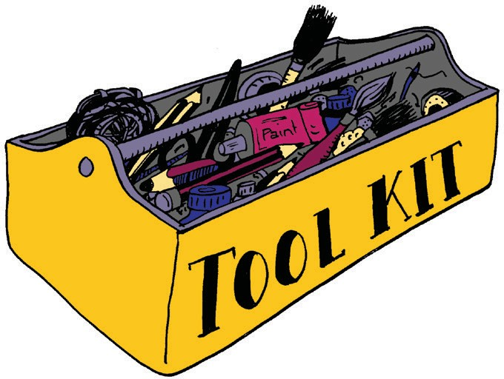

Jayne Earnscliffe
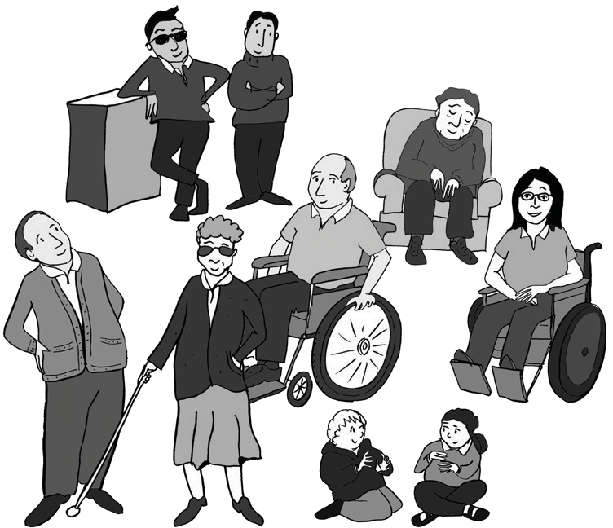

How to Use This Toolkit

This toolkit can either be used as a step- by-step process to follow when creating an exhibition, or selected sections can be used to re-think how you can make certain activities more accessible. This toolkit also contains a useful glossary of
terms, an index of where to go for further support and case studies to showcase the benefits of creating accessible exhibitions.

As director of leading, disabled-led access design company, Earnscliffe, Making Access Work, Jayne has contributed to the success of numerous, access award winning museum, art and heritage projects for over 28 years. With a unique specialism in inclusive exhibition design Jayne has embedded high standards of accessibility across a vast client portfolio that includes the V&A, British Museum, National Maritime Museum, Science Museum and Grand Egyptian Museum, Cairo. Passionate about inclusive design, her pragmatic, non-prescriptive, creative approach places people at the heart of the design process. Jayne whole-heartedly endorses ‘Accessible Exhibitions for All’. “This will give museums the tools with which to create environments in which everyone can engage with collections and activities in a full and meaningful way”.

Getting Started

This section has been developed to provide practical advice for organisations such as museums, archives, disabled people’s organisations and community spaces, who are interested in creating accessible exhibitions and events for deaf and disabled people. It has been broken down into sections and much of this guidance can be used on existing as well as new displays.

“To truly represent a place and its people, you have to immerse yourself in their story and to give over some of the narrative control to them”
Charlotte Kingston, History of Place Curator

Creating Content

Unfortunately, the nature of archives, collections and records relating to the history of deaf and disabled people means there are rarely any documents from the perspective of those with lived experience. The majority of the records have been created by gatekeepers and decision makers, such as teachers and doctors. This issue can be addressed by creating new content which brings in disabled people’s voices of today. Potential ways to do this are:

- Work with people who have a lived experience of disability to share their perspectives in their own words.
- When confronting some of the more uncomfortable contents of historic material such as attitudes and language, work with disabled people to discuss this. You might not be sure what disabled people of the time thought, but by using hindsight and applying current thinking you can create an interesting dialogue.
- Modern reflections of historic material can be turned into new content by creating oral histories, films and interactives. Create additional content by working
with disabled artists who can interpret the historic material. This new content could then be potential ‘objects’ for inclusion in the museum’s collections.
- Work with the museum to encourage new acquisitions into their collections that reflect the stories of deaf and disabled people not yet represented in their collections.

Object and Image Selection

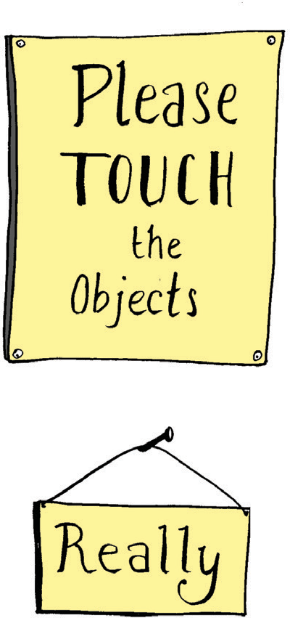
The advice outlined in this section can be applied to exhibitions and displays that relate directly or indirectly to the history of
deaf and disabled people. When the process of choosing objects begins you should think about interpretation and access points throughout the exhibition, ensuring that accessible object and image selection is not an add-on, but an integral part of the narrative from the outset. Ask yourself the following questions:

  - If an object has been selected to represent a section of a story, how this will translate as a tactile object, or an interactive experience?
  - If an object or image cannot be made accessible, then should this story/object/image be included?

We recommend that when selecting your objects and images, you make careful and collaborative selections, in conversation with those who have a lived experience of the story you are trying to tell. Better still, have them make some or all of the decisions. Some objects and images, however good their story, might not be appropriate for display without careful interpretation. They may not hold the same meaning for a
disabled person as someone with no lived experience of disability. They may also represent troubling attitudes and language so, where possible, consult with disabled people about how to approach the subject and the language that should be used.

Curating the Content

In deciding how to tell stories, it is important to ensure that the voices of people involved and affected by the history are accurately represented. This can be challenging but the aim of achieving diversity, inclusion and representation should be central to all work.

Using the methods outlined in the ‘Creating Content’ section of this toolkit, existing objects can be re-interpreted, or new content can be interpreted for display. In curating content, work with deaf and disabled people in the creation of copy, object selection and interpretation of content. Integrate their stories into the narrative of the exhibition and enable collections and objects to be shown in new ways.

Getting Started (contd.)

Safeguarding

If you are also engaging with young people, organisations should have an up-to date and robust safeguarding policy or statement in place. You should not be working with young, deaf and disabled people if you do not have one. This is intended to protect the young people you work with, keeping them safe and provide clear guidance on how to respond to any concerns. Safeguarding awareness training should be provided to all people involved in your project or activity. The NSPCC provide helpful support and guidance in this about this on their website. In addition to safeguarding policies, we recommend that any adult working with young,
deaf and disabled people should also provide a current, enhanced Disclosure and Barring Service (DBS) check. This should include staff, volunteers and facilitators.

Accessible Design

Exhibition design plays a crucial part in creating an accessible exhibition. We recommend you:

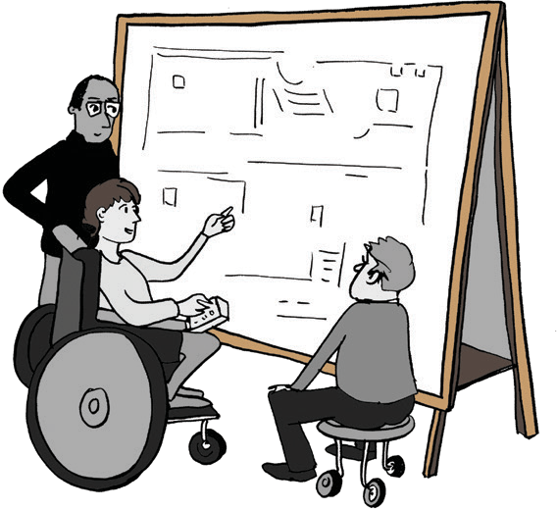
  - Be bold and aim for 100% accessibility; even if you don’t achieve it, it is better to have tried and fallen short than to have not tried at all.
  - Work with artists, as well as designers, to approach the exhibition design creatively.
  - Work directly with disabled people to get their opinions on what does and does not work.

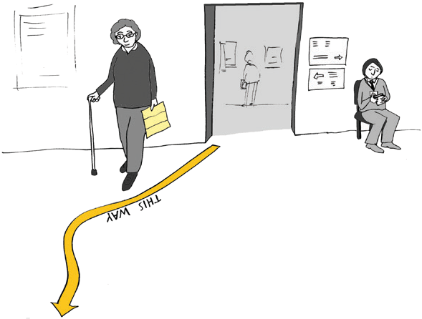
In creating the physical elements of the display, implement these easy principles in your design. They have a huge impact on increasing accessibility:

  - Mount displays at a lower level; 75 cm from the ground to the underside of worktop or display case is recommended.
  - Ensure that cases allow for wheelchair users to get close to the case with ‘knees-under’ access (i.e. the display units
should be hollow underneath like a table). Display case hoods should be transparent on five sides, particularly the front, so that objects displayed inside can be viewed at any level, not just from above. Wherever possible object mounts should
be at an angle to enable objects to be easily viewed.
  - Use a brightly coloured guide line to act as a visual trail through the whole exhibition. This helps sighted and visually impaired visitors alike to navigate the space.

Top Tip:

You may have wanted to include lots of audio and interactive elements for visually impaired visitors, but visitors with autism or other impairments may find it overwhelming.
Consider having scheduled and publicised quiet times when audio is turned off or down.

- Use large print text panels, size 16 point as a minimum. Ensure you use an accessible font such as Gill Sans or Arial and present these against a background colour contrast for example, black text on an off-white background. Off-white panels should be used instead of bright white panels as this makes it more accessible
for those who find reading difficult or for people with visual impairments.
- Consider working with a visually impaired creative writer to develop an audio description for your exhibition. This could, for example, present material from the viewpoint of a historical character or offer an opportunity to have a dialogue between past and present characters, allowing reflection on difficult language or themes. Where possible commission disabled actors to perform the script.
- Work with someone who has experience of audio description in a museum or cultural capacity, so they can ensure key elements of orientation,
and the describing of objects, are included within the script.
- Use hand held, single-cup, audio devices as opposed to traditional headphones. This enables people who do not like wearing headphones, or those who cannot put them on their head, to independently access the content.
  - Include BSLI and subtitles on all the AV media and provide a

Top Tip:

Ensure that people who read Braille check
Braille exhibition labels to ensure they are correct!
standalone BSL introduction to the exhibition. It is important to work with a deaf person to present this information rather than using hearing interpreters although you will need to use interpreters during filming to aid communication between actors and filmmakers. We believe deaf people should provide the filmed interpretation because deaf people will not only
use sign language innately, but they have a good understanding of deaf culture which can help with language detail.

- Be aware of the compatibility issues of AV technology. AV can be a great tool in creating accessible interactives, however it is important to check compatibility with AV hardware and access equipment such as screen readers. Ensure on-site staff know how to use the equipment and are able to reset it should that be required.
- Consider using Braille guides to provide further interpretation to Braille readers. Text only Braille guides are relatively inexpensive to have printed. You can also consider creating tactile images, however not every image is suitable for re- creating in tactile format. Simple forms and textures work best. Manufacturers generally need at least three months lead-in time to produce tactile images and may take longer and tend to be more expensive than regular printing.

Getting Started (contd.)

- Display tactile elements both at an angle and flat. This is based on advice from audiences and specialists, as wheelchair users usually need tactile objects to be at an angle whereas some people with visual impairment prefer them flat. We recommend you consult with your audience to determine which method would suit them best. Fix tactile elements as close to the front of the display units as possible to allow those with limited upper body reach to enjoy them.

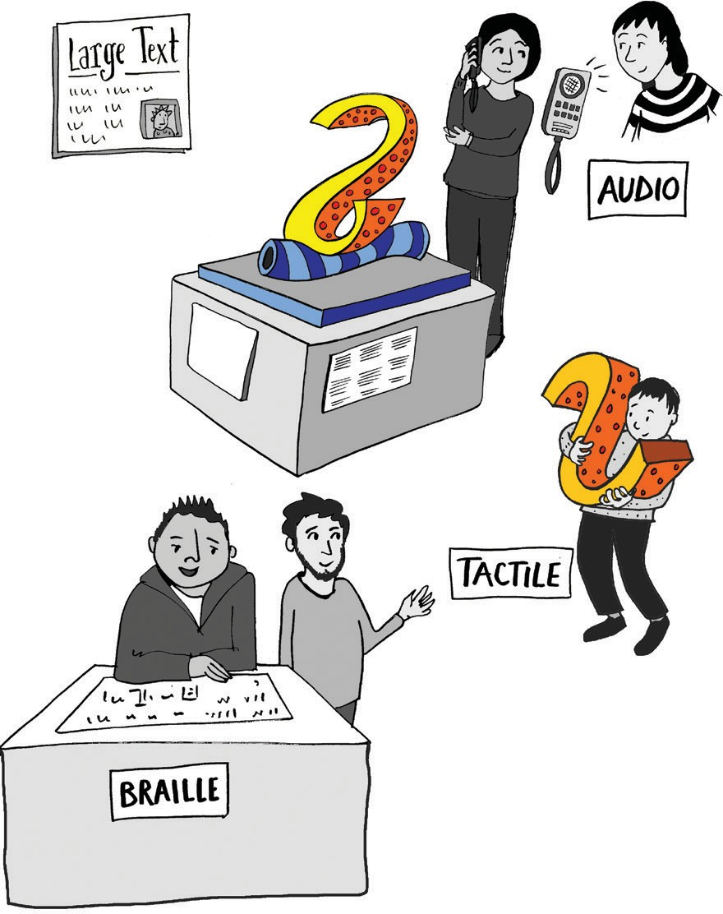

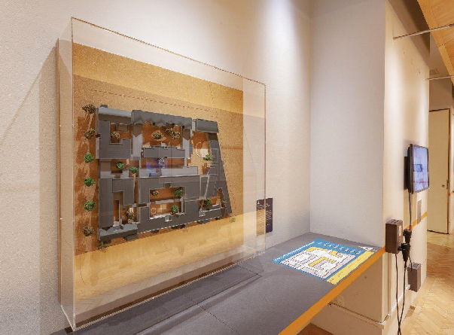
Tactile plan illustrating model of building displayed in ‘Without Walls: Disability and Innovation in Building Design’ at the Victoria & Albert Museum, London. ©Victoria and Albert Museum, London.

- Incorporate tactile re-creations of some of the objects on display. This helps to make your objects more accessible to everyone, and particularly
for blind and visually impaired visitors. If you are interpreting a physical space, use tactile floor plans of the buildings so that blind and visually impaired visitors can understand the physical layout of the buildings. For our exhibition at
the Museum of Liverpool and our display at the V&A Museum, we worked with Tactile Studio to create tactile models and maps. You can find out more about them at the end of this guide.
- Create a multi-sensory experience. For example, you can use smell pots to provide an experience which engages with multiple senses.
- Use accessible formats for the publicity of your exhibition. This can include large print and Braille versions of the exhibition poster and flyer, particularly when marketing your event to
organisations that have a blind and visually impaired audience. You can also create audio versions
of your marketing materials for social media.

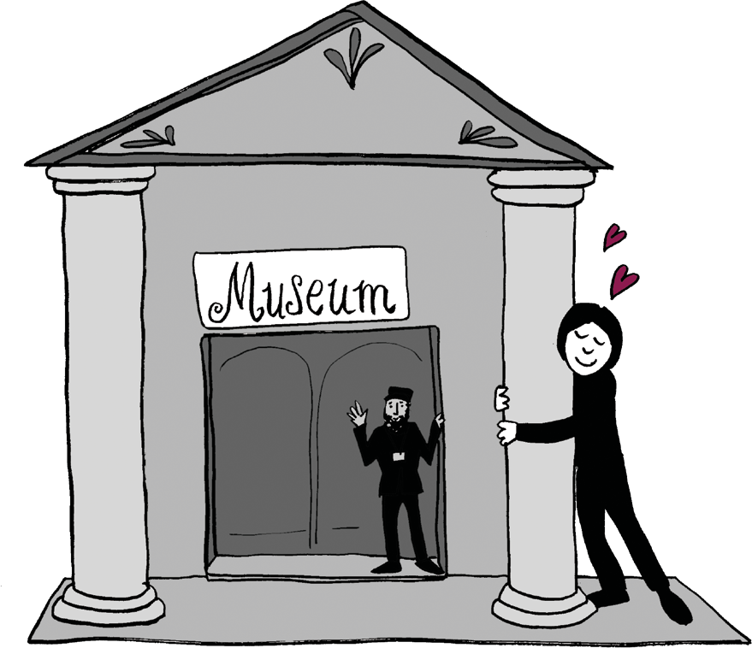
Partnerships

Working in partnership with another organisation can add value to your exhibition. You might create a partnership by working with a host museum (as
the History of Place project did), or by working with an organisation that work with deaf and disabled people. If you decide to work collaboratively, this advice could be helpful:

  - It is never too early to start planning your partnership. Getting your partners on board from the earliest stages of a project will allow both parties to generate institutional support and to shape the project, which will in turn lead to greater commitment throughout its course.
  - Partnership work takes more time than working alone. Build in sufficient extra time at every stage to allow for the discussions, consultation
and complexities that partnership working will entail.
  - Agree between partners what the look and feel of the exhibition will be, taking into consideration any existing brand guidelines.
  - Build support within each institution for the project by emphasising the benefits of partnership working, including knowledge exchange, skills development, and the potential for expanding audiences.

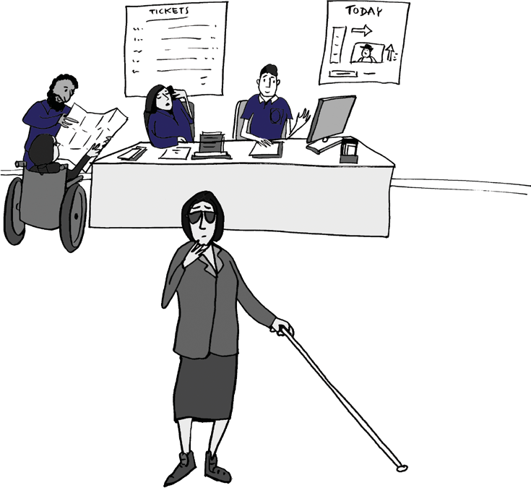
    - Work with organisations with a similar ethos and who have a desire to do things differently.
    - If you are working with a museum think about how you can engage with all departments, from front of house to marketing. For example,
the front of house team is really important as they are the people who will often be the first point of contact to your visitor. They should understand the different elements
of the exhibition as this will enable them to speak with visitors about the exhibition and create a positive visitor experience.

Getting Started (contd.)

  - Communicate effectively and be prepared to compromise along the way. Be sure to take time to explain why certain things need to be implemented to ensure greater accessibility.
  - Be flexible, set internal deadlines and be clear on responsibilities.
  - Understand who makes the decisions about each element. This could be yourselves, a curator from your partner museum or members of the marketing, exhibitions, education or IT teams, depending on which element of the exhibition you are working on.
  - Consider basing a member of your team at the host institution. Or, if you are the partner museum, consider offering to host a member of a specialist team.
  - Undertake disability equality training for your team and any partners you may work with. This will give staff and volunteers the skills and confidence to support deaf and disabled people and will ensure that the people you are engaging with have a positive experience or your activity and organisation. Accentuate can support this training or can advise on other organisations which also provide these services.

Events

Developing a public programme of events and activities is an integral part of creating an accessible and engaging exhibition for your audiences.
If you decide to do this, the following can help make them more accessible:

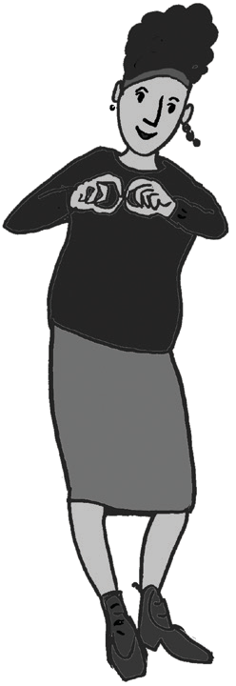
    - Run events throughout the exhibition period in order to engage wider audiences.
    - Where possible include a BSL tour, an Audio-Described tour, and specific tours for disabled people’s groups.
    - Where possible tours and events should be led by a disabled person and BSL tours by a Deaf person. They will have a unique way of engaging with deaf and disabled audiences and will often have access to wider networks, or have their own following of people who then may attend events. You will need to book a BSL Interpreter alongside your Deaf tour guide to provide communication between BSL and non BSL speakers.
    - Use reflective workshops or have a ‘relaxed presence’ of volunteers who situate themselves at the exhibition in regular slots to discuss the exhibition and its themes with anyone who is interested. This gives alternative avenues of access for people and opens up different levels of engagement.

At the Guild of the Brave Poor Things building in Bristol, they displayed a large flag. Therefore, we ran two flag making workshops to creatively respond to the themes from within the archival material and to capture the opinions of the disabled people taking part in
the workshops. We aimed to bring this heritage to life by exploring contemporary perspectives.

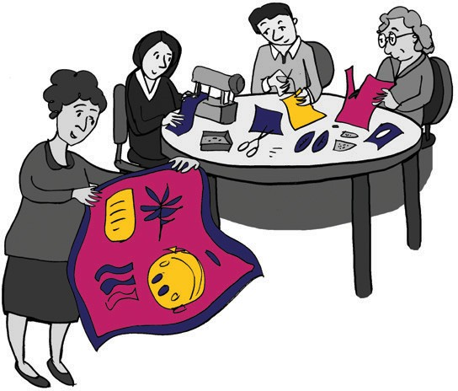

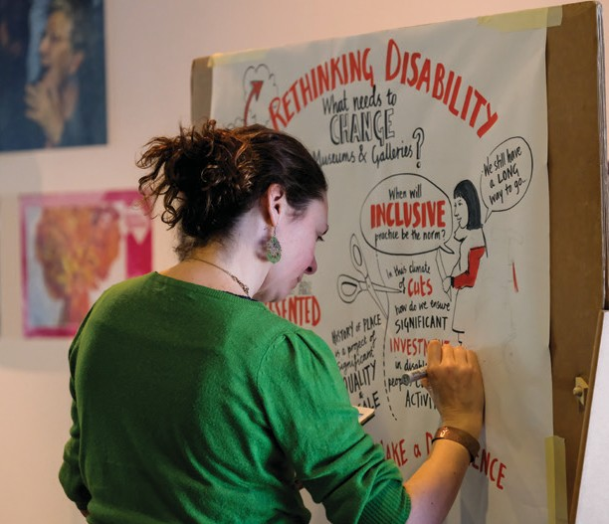

Visual Minutes being created in real-time at History of Place’s ‘Rethinking Disability’ Symposium
  - Remember, not everyone enjoys or has a lot of experience of museums. Representing deaf and disabled people and providing multiple, accessible ways to engage with the exhibition can
help. Take your time in developing your relationship with the community. Use your marketing or outreach departments to reach local groups you are trying to engage with. This should be done at least a few months prior to the exhibition opening. If you are consulting with a disability group, ask if they can share your exhibition with their members and network.
  - Be flexible to adapt tours and events to suit the group you are working with.
  - Use creative sessions to explore themes relating to disabled people; this is effective for engaging all audiences and can generate thought-provoking conversations about the topic or the lived experiences of participants.
  - Where possible, consider hosting a more formal event, such as a conference or symposium. This can be aimed at industry professionals and specialist-interest groups. Formal events can
engage with a wider audience than the exhibition alone, can allow deeper analysis of the subject matter, will involve a wider range of voices, and affords networking opportunities for the participants.
  - You can also create a visual record of these events, using visual minutes to illustrate the discussions. To find out more about visual minutes please refer to the ‘Glossary’.
  - It is essential to take into account the audience requirements in running any event. Consider what kind of events they would feel interested and confident in attending. Incorporate the needs, opinions and access requirements of all involved and adapt the event to suit, for example providing palantypists and BSLI.

Ethics

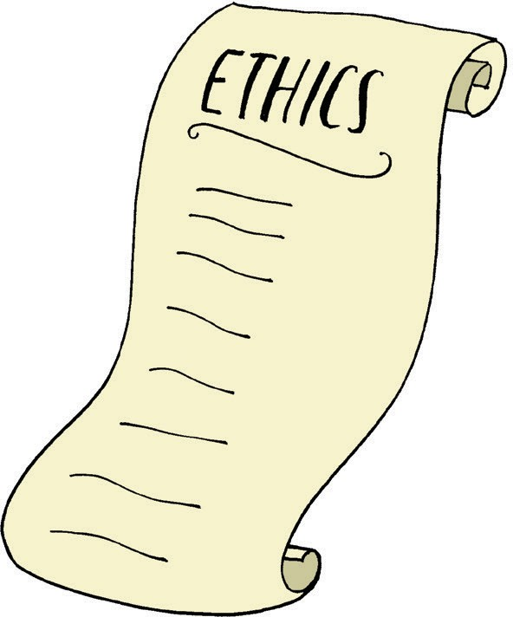
Here are some key things to consider regarding the ethics of creating accessible exhibitions:

    - Understand the social model of disability and apply this in choosing appropriate language as well as thinking about the barriers deaf and disabled people face. To find out more about the social model, refer to the Glossary.
    - Consider why you have included or excluded content.
    - Some items you choose to include might offend some visitors, as might the exclusion of other items. Be sure to think about the consequences of the content and be able to justify and explain your decisions to your audiences.
    - It is challenging to be fully accessible for all. Be honest about what you have provided and think about ways of adapting the material or spaces depending on your audience.

Whilst History of Place was creating one of our exhibitions, one of the sites had allegations of historic abuse made against it. Rather than interpreting these allegations or excluding them we chose to have former students share their experiences in their own words via oral histories of their involvement with the site.

- It is ethically challenging to create narratives about histories which are previously unknown. Particularly when the archive material and objects collected may only represent the views and experiences of those in positions of power, not those who have been directly affected. In the case of
disabled people’s history, work with disabled people to help interpret the archive material. One way of doing this is to set up a consultation group which you can meet with to discuss key themes and object selection.

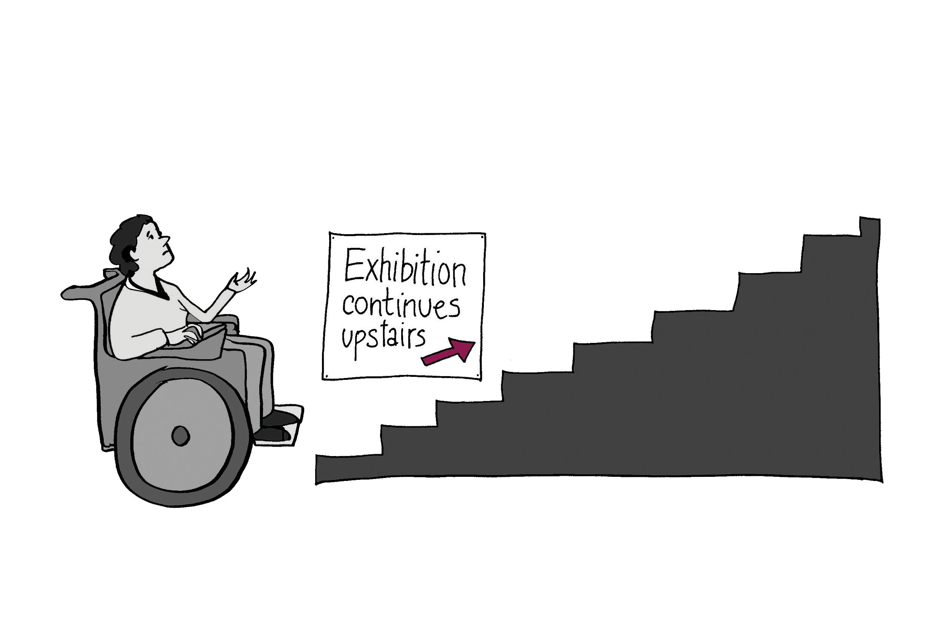
The Museum Association’s ‘Code of Ethics for Museums’ outlines a number of ethical principles to guide museums. The following are particularly relevant in this context:

Public engagement and public benefit:
Actively engage and work in partnership with existing audiences and reach out to new and diverse audiences.

Treat everyone equally, with honesty and respect.

Provide and generate accurate information for and with the public. Support freedom of speech and debate.

Stewardship of collections:
Maintain and develop collections for current and future generations.

Individual and institutional integrity:
Build respectful and transparent relationships with partner organisations, governing bodies, staff and volunteers to ensure public trust in the museums activities.

1. Museum Association, Code of Ethics for Museums, 2015

Funding and Planning

There are several ways to fund accessible exhibitions and events. The History of Place exhibitions were part of the larger History of Place project supported by the Heritage Lottery Fund. Whilst the list of potential funders is lengthy, a good resource for finding the right funding for your project is the Directory of
Grant-making Trusts and Foundations, published by the Directory of Social Change (https://www.dsc.org.uk/publication/the-directory-
of-grant-making-trusts-201819)

Additionally, potential funders who support such work include:

  - Arts Council England, in particular their Grants for the Arts, https://www.artscouncil.org.uk/funding/applying-grants-arts
  - Paul Hamlyn Foundation, https://www.phf.org.uk/
  - Esmée Fairburn Foundation, https://esmeefairbairn.org.uk/
  - Heritage Lottery Fund, https://www.hlf.org.uk/

Your development team or consultant can advise on who to approach and how to apply for funding.

Realistically Planning Your Costs

Delivering a range of accessible elements in your exhibition will cost more money, but that should not be an excuse not to do it. Make sure you consider the costs of increased accessibility in advance and if you are applying to funders make sure you have included these costs in your application. The following will help you consider some of the costs that you may want to include:

Item | Breakdown of Estimated Costs* | Estimated Total Costs*
Audio description tour | Creative writer - £500, actors to perform the script - £250 per person, recording studio - £400, sound editor - £300,  audio describer - £250 per day | £2000 - £3000
Tactile models | Ranging between £1000 - £3000 depending on complexity | Dependent on the number of models included
Tactile plans | £2000 per plan | Dependent on the number of models included
Braille guide | Copies can be produced in small numbers  £200 - £300 | Approximately £300
Sensory pots | A variety of smells available between £20 -  £50 | Approximately £150
BSL interpretation | BSL actor - £350 per day, BSL interpreter - £350 per day, Film studio -  £1000 - £2000 green screen/camera/ lights- editor - £300 per day | £2000 - £3000
Bespoke display cases | Between £500 - £1500 | Dependent on the number of cases needed
Hand held audio devices | Approx £40 per handset, plus one unit per handset for storing and playing the audio | Dependent on the number of audio devices included
AV equipment | Screens, audio players, media players (you may want to build housing for each screen which will incur design and manufacturing costs) | £5000

*please note these costs are indicative.

Exhibition and Event Top Tips

Here are our top tips for producing an accessible exhibition and events:

  - Accessibility isn’t just about telling the story in an accessible way but also facilitating deaf and disabled people to tell their own stories. Your exhibition can provide the opportunity for a minority and marginalised community to share their heritage on a national level.
  - Work with deaf and disabled people to develop the content. This should include developing the narrative, selecting objects, creating the AV media and providing lived experiences.
  - Identify a variety of methods to tell the narrative so that it is sensory, accessible and fun.

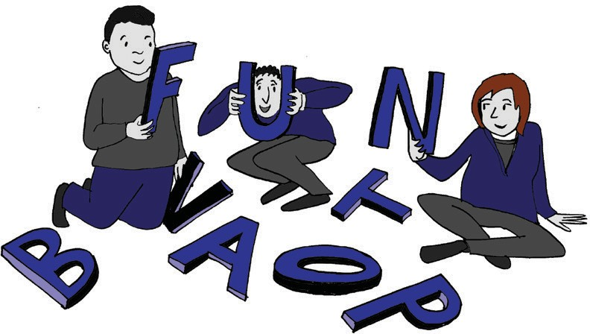
    - Consider your hardware. What will work in the space, the power sockets you have available, and what ongoing AV support you will need from technical and gallery staff during the exhibition run.
    - Provide large print guides, Braille guides, Easy Read guides and contrast print guides.
    - Ensure audio description speakers are activated when they are picked up rather than playing on a loop as this can confuse and frustrate visitors.

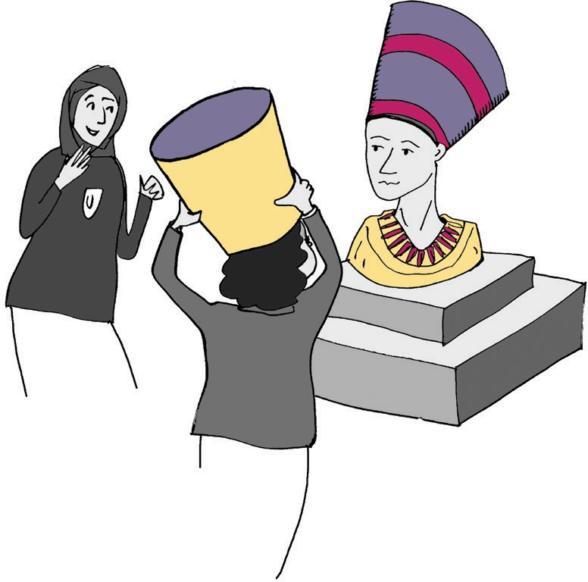
  - Objects in a case will not be accessible for blind and VI people so create tactile models and handling versions of significant objects as these create a more interactive experience for all visitors as well as increasing accessibility.
  - Transcribe handwritten historic documents for legibility and clarity.
  - If possible, when providing audio interpretation or audio description, have disabled actors
(as characters) telling their stories.
  - If possible, hold your events within your exhibition space to provide a relevant and immersive experience.
  - Consider using a visual minute taker to capture the event, themes and
conversations in a visually creative way.

Where to go for Support

The following can provide support and materials to help you put on accessible exhibitions and events:

  - RNIB, for Braille, raised letters and large print document production and objects www.rnib.org.uk
  - British Deaf Association, for support and information www.bda.org.uk
  - NRCDP, for booking BSLI, lip-speakers, palantypists and audio describers www.nrcpd.org.uk
  - Mencap Liverpool, for producing Easy Read documents www.mencapliverpool.org.uk/want-help/easy-read-services
  - Heritage Lottery Fund, for support and advice www.hlf.org.uk/running-your-project
  - Museum Associations, ‘Code of Ethics’
www.museumsassociation.org/ethics/code-of-ethics
  - Oral History Society, guidance on recording lived experiences www.ohs.org.uk/advice/ethical-and-legal
  - VocalEyes, resources relating to working with blind and VI people www.vocaleyes.co.uk/services/resources
  - Accentuate, a range of toolkits for working with deaf and disabled people www.accentuateuk.org/toolkits

Find out More

If you are interested in the recommendations in this toolkit, and would like to find out more about the History of Place project, head over to:

  - History of Place, www.historyof.place
  - Accentuate, www.accentuateuk.org
  - Screen South, www.screensouth.org
  - Museum of Liverpool, www.liverpoolmuseums.org.uk/mol
  - M-Shed, www.bristolmuseums.org.uk/m-shed
  - V&A, www.vam.ac.uk
  - 360 degree videos of the exhibitions, www.historyof.place/multimedia

Impact

These testimonials below demonstrate how working with disabled people through the History of Place project has delivered benefit for the organisations and individuals involved, in addition to the audiences they have reached.

Charlotte Kingston, History of Place Curator:

“Working on the three exhibitions for History of Place was an extraordinary experience and a huge honour. Uncovering these hidden stories of architecture, people and place, and presenting them as powerful statements for new audiences felt like a radical, forward-looking moment in the history of museums. The responses, both anecdotal and formal, to the exhibitions have been overwhelming and enlightening, showing us that the most successful exhibitions are ones that are truly rooted in the audiences and places they seek to explore.

The most important lesson I learnt through creating the exhibitions was that to truly represent a place and its people, you have to immerse yourself in their story and to give over some of the narrative control to them. By building those links into the communities of each place and trusting them with the process, we were able to co-create items for display, co-write interpretation, and co-select objects and methods of display. The practical solutions we found to solve many of the design problems were not unique to our project, but what was different was the effort to embed all of them simultaneously alongside the significant amount of consultation. It was eye-opening to actually be able to ask people with lived experience of the topics were were presenting: what interests you about this story and how would you like to access it?”

Catherine Johnson, Senior Exhibitions Officer at National Museums Liverpool and
Kay Jones, Curator of Urban Community History at the Museum of Liverpool:

“There were many positive outcomes for National Museums Liverpool (NML), specifically the Museum of Liverpool, as a result of being a partner on the History of Place project. The wider impacts included learning more about how other organisations and museums represent, and work in partnership with, disabled people, and increasing the awareness of the Museum of Liverpool and its work with communities and partner organisations.

Developing ‘The Blind School: Pioneering People and Places’ exhibition in partnership with History of Place was a fantastic opportunity to tell the significant story of the Liverpool School for the Blind in the Museum of Liverpool for the first time. It brought about opportunities for us to learn more about objects in our collections from blind and visually impaired visitors. We were encouraged to use our exhibition gallery in different ways and trialled new, accessible approaches to help visitors orientate themselves around the exhibition space (i.e. a yellow band as a guide line). We welcomed more disabled people to the Museum as a result of raising the profile of deaf and disabled people’s history by conveying experiences through the authentic voices of these individuals, told from their perspective, which was very impactful. Delivering exhibition

tours to members of local disabled groups who wanted to create similar accessible exhibitions ensured best practice was shared.

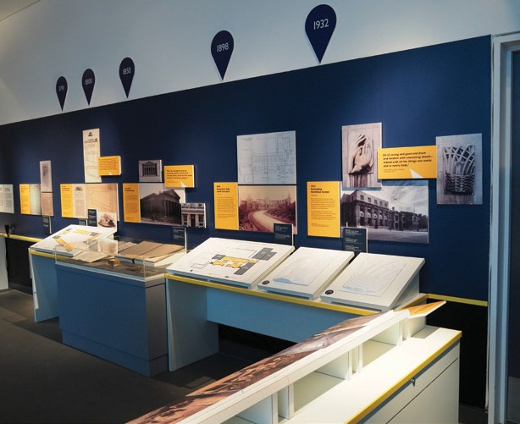
‘The Blind School: Pioneering People and Places’ exhibition, on display the the Museum of Liverpool
Legacies of the project include encouraging NML to implement accessible interpretation, provision and representation from the beginning of the process for temporary exhibitions. It was good to explore the different ways of promoting our exhibitions to disabled audiences (i.e. talking newspapers, tactile posters). Hopefully, we will continue to use these methods in the future. Staff training delivered by people with lived experience of disability was another positive legacy for the wider organisation. For future exhibitions we will ensure the accessible delivery of associated learning events are lead by disabled people wherever possible. We would also
like to develop more creative audio descriptions as a result of the exhibition. Generally, we have an increased awareness of the diverse needs of different disabled people, have made good contacts and have developed relationships which will be beneficial in the future.

Practical lessons learned include; ensuring that people who read Braille check the Braille exhibition labels to ensure they are correct, making sure technology is compatible on gallery, being clear on roles and responsibilities, the sign off process and editorial control within the partnership from the outset, the importance of undertaking in-depth evaluation of display space and accessible elements with disabled people (i.e. was yellow band useful?).”

Olivia Horsfall Turner, Senior Curator of Designs at the Victoria and Albert Museum in London:

“The relationship with Accentuate has been longstanding, almost four years since we met and discussed the potential of having a display in the Architecture Gallery during the History of Place project, if it were successful in gaining the HLF funding. We fed into the initial HLF proposal which I think is very important, having that discussion with partners at the earliest stage. We celebrated with them when the funding was approved!

Since then it has been quite an intense process of collaborating. It was interesting to see how different museums were responding to the same parameters. At the V&A we have felt conscious that we have very specific guidelines about how displays and exhibitions are produced, so we couldn’t necessarily be as flexible as we might have wanted to be. Especially given the nature
of the subject, in that it is supposed to be responsive and breaking boundaries. We did try to push those boundaries as much as we could and be a flexible as we could. Using audio visual description was a completely new thing for us and we wanted to take this opportunity to see what it was like, whether it would work and how visitors might respond to it.

Impact (contd.)

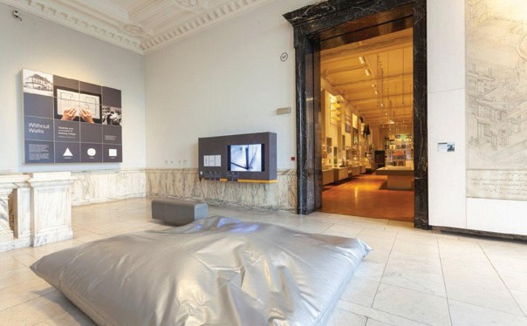
Entrance to the ‘Without Walls: Disability and Innovation in Building Design’ Display at the V&A ©Victoria and Albert Museum, London.

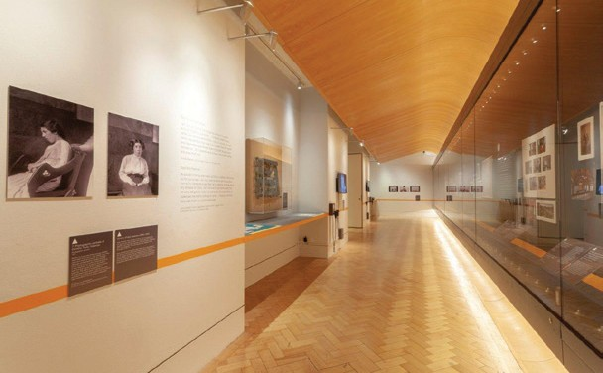
‘Without Walls: Disability and Innovation in Building Design’ Display at the V& A ©Victoria and Albert Museum, London.

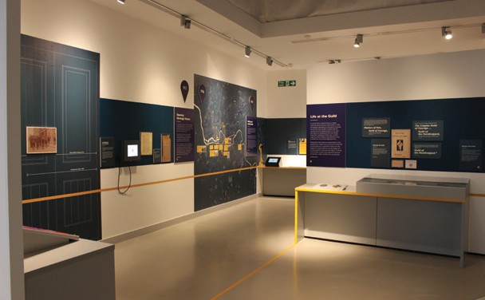

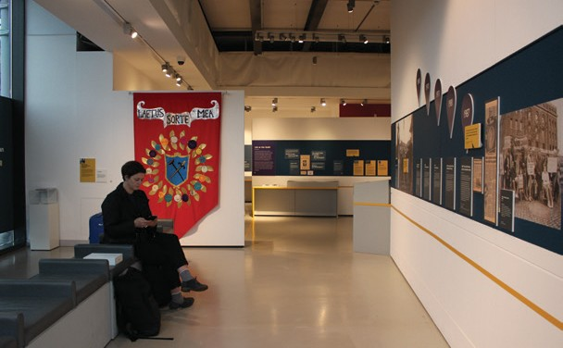
Two photos showing views of ‘Brave Poor Things: Reclaiming Bristol’s Disability History’ on display at M Shed, Bristol
The partnership focussed attention on an area of the collection and an area of architectural practice which has not been looked at by the Museum before. We have been able to enhance our collections in being made aware of architects who we didn’t know of before.
We have brought things into the permanent collections, so this project has left its mark on what is included within the collection, that is really valuable. It has been a valuable professional development opportunity for the Curators involved but also for the Design Team. We have all had to think in different ways, respond to different challenges, so it has manifested its impact in many different ways.

In terms of challenges, I don’t think any of us imagined how much time all of the preparations would need. That’s partly to do with things taking time in museums anyway but also, working
collaboratively with other organisations. We had to build in time for consultation, which meant we had to plan ahead more, which meant that we were really pressed for time at points.
I really enjoyed this whole collaboration, it has been a really interesting experience for me. It has broadened my horizons, it has broadened my experience and it is not an exaggeration to say that I now look at the world differently.”

Karen MacDonald,
Engagement Officer (Exhibitions) at Bristol Culture:

“Working with Accentuate on ‘Brave Poor Things: Reclaiming Bristol’s Disability History’ has been rewarding and has challenged us to take a fresh look at our assumptions about the accessibility of our exhibition design. Through the exhibition new visitors, disabled and non-disabled, and different community groups have visited M Shed, and left a wealth of information about their thoughts and experiences of disability and attitudes towards disability today. The AHOP Project Coordinator and a team of volunteers and young people worked with Bristol Archives collections to recover and retell really powerful stories about the city and its residents of 100+ years ago. The words and voices of disabled actors and interpreters brought a whole new creative dimension to making the exhibition’s content accessible to more people, and bringing the past to life.”

Glossary of Terms

Some of the terms in this toolkit might be new to you so we have put together this helpful glossary to explain some of the terminology:

- Audio description: an additional narration track intended primarily for blind and visually impaired consumers of visual media. An audio description consists of a narrator describing what is happening on the screen or stage during natural pauses in the audio, and sometimes during dialogue if deemed necessary. It is also used to describe visual material such as photographs and paintings.
- Blind/visually impaired (VI): visually impaired means someone has a reduction in their vision which is not altered by the use of glasses or contact lenses. A blind person may have some vision, see shadow and light, or have no vision.
- Braille: Braille is a tactile writing system used by some people who are visually impaired. It is traditionally written with embossed paper. Braille users can read computer screens and other electronic supports using refreshable braille displays.
- BSL/British Sign Language: is the first, or preferred, signed language of some Deaf people.
- BSLI/British Sign Language Interpreters: people who relay conversation between Deaf British Sign Language users and hearing people. The interpreter will translate BSL into spoken English and spoken English into BSL for easy communication between both parties.
- Contrast print: contrast print describes the high contrast between the text and backgrounds (i.e. black and off-white) making the text more visible to people with low vision.
- D/deaf: describes people who are Deaf (British Sign Language users) and deaf (who are hard of hearing but who have English as their
first language and may lip read and/or use hearing aids).
- Easy Read: Easy Read is a method of presenting written English to make it easier to understand for people with learning disabilities. Typically, Easy Read uses sentences that should be no more than ten to fifteen words and each sentence should have just one idea and one verb.
- Large print: refers to the formatting of text in which the font, and sometimes the medium, are considerably larger than usual, to assist people who have poor vision.
- Orientation (within audio description): provides key pieces of information to the listener that orientates them within the space such as where display cases are situated, which direction to face and how to move around the space.
- Relaxed spaces: the creation of a space that is comfortable for everyone, especially people who would benefit from a more informal experience.
- Social model: the social model of disability identifies systemic barriers, negative attitudes and exclusion by society (purposely or inadvertently) that mean society is the main factor in disabling people, not the impairments they may have.
- Visual minutes: visual minutes are a live, illustrated record of conferences, events or meetings. The minutes unfold during the event and the information is brought to life with illustrations and colour. Visual minuting, or graphic recording, pulls out the key themes and messages making the information digestible.

Case Studies

Over a period of three years, the History of Place project developed three exhibitions with national partner museums. These were:

- ‘Brave Poor Things: Reclaiming Bristol’s Disability History’ in partnership with M Shed, Bristol
- ‘The Blind School: Pioneering People and Places’ in partnership with the Museum of Liverpool
- ‘Without Walls: Disability and Innovation in Building Design’ in partnership with the Victoria & Albert Museum, London
This section contains case studies of key learning taken from developing these exhibitions.

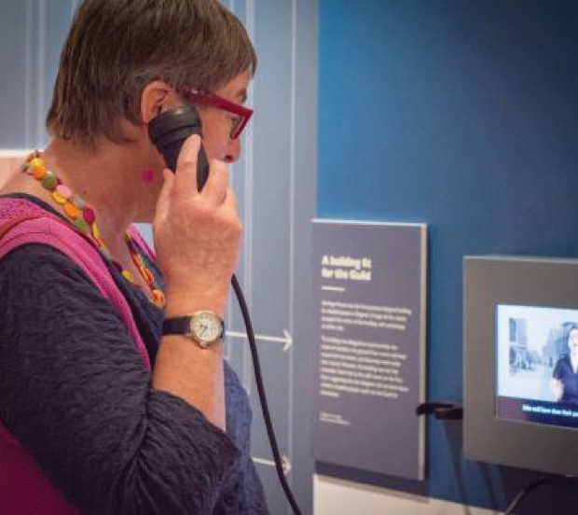
Case Study 1:
‘Brave Poor Things: Reclaiming Bristol’s Disability History’ Audio Tour, M Shed, Bristol

Visitor using a hand held listening device
Who was involved: The M Shed curatorial team, Bristol Archives Team, the Accentuate History of Place curatorial and project teams, Screen South, an independent
writer and actors who identify as disabled.

What we did: During the development of the exhibition we produced an audio tour using additional narrative and
atmospheres to create a more engaging experience for visitors. The purpose of this was to ensure visually impaired people were able to have an as in depth experience as sighted visitors. We worked with a script writer with experience of writing plays
and who was also visually impaired. The script followed two characters describing the exhibition, one from the past and one from 2018 who debated language and differences in social opinion. The audio description was made available on hand held devices and Discovery PENS in the exhibition and online.

Impact and lessons learned: The audio description was integrated within the exhibition by installing the audio handsets throughout and splitting the audio description into chapters. This approach created a more accessible experience for all, including for people with learning disabilities or autism, who could use the audio description as it broke the text into manageable chunks of information.

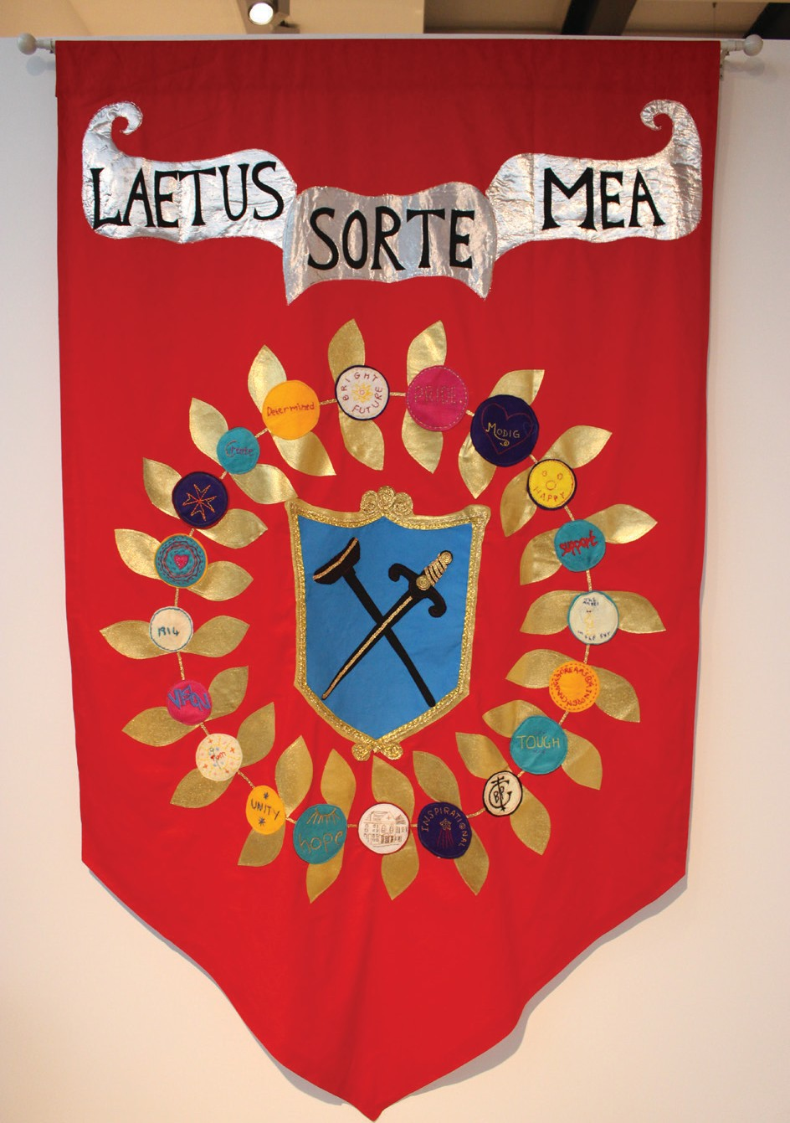
The flag recreation which was on display in the ‘Brave Poor Things: Reclaiming Bristol’s Disability History’ exhibition in M Shed

Case Study 2:
Flag Making in Bristol: Interpreting the Archives

Who was involved: The Accentuate History of Place project team, volunteer researchers, a local artist, a BSLI, a group of participants from the disabled community and non-disabled participants.

What we did: During our research, conducted predominantly by volunteers, we discovered that The Guild of Brave Poor Things, used flags to share their motto and logo. One flag was displayed in a prominent position in the Guild Heritage building but was lost when the building closed in the 1980’s. We wanted to make a modern recreation of the missing flag for inclusion in the exhibition. We ran two flag making workshops to creatively respond to the themes from within the archival material and to capture the opinions of the disabled people taking
part in the workshop. We aimed to bring the heritage of The Guild of the Brave Poor Things to life through contemporary perspectives. These workshops
were attended by people previously engaged in the project, as well as new audiences, who used craft- based methods such as sewing, felting, embroidery, drawing and applique, to create the modern-day flag.

Impact and lesson learned: Participants were able to share skills and support each other through
the process of this activity. Many of the themes discussed during the creation of the flag were challenging however, exploring them in a relaxed and collegiate environment made them easier to discuss.
Feedback received from workshop participants was resoundingly positive and demonstrated
a demand for more workshops like this.

Case Studies

Case Study 3:
‘The Blind School: Pioneering People and Places’ Exhibition, Museum of Liverpool

Who was involved: The Accentuate History of Place project team, the Museum of Liverpool’s Curator of Community History and wider National Museums Liverpool team, a volunteer research group, a mixture of disabled and non-disabled people, a disabled scriptwriter, an audio describer, a
deaf presenter, film makers and former students of the school.

What we did: We worked with the Museum of Liverpool to create an exhibition which explored the history of Liverpool’s School for the Blind. The general history of the school is relatively unknown in Liverpool. Furthermore, the particular significance of the founders involved and the fact it is the oldest school of this type is unknown.

The exhibition aimed to contextualise the school among other blind schools of the time and share the significance of the design of the buildings. It explored what it was like to be a pupil at the school from daily routines, to punishments, and from leisure activities to crafts and skills with the objective of encouraging people to think about historic and modern attitudes towards blind people.

Combining the authentic voices of former pupils with accessible design, we constructed a temporary exhibition space which integrated AV media, images, text panels, objects and tactile elements to create a physical space that allowed visitors to travel through the narrative. The exhibition design went through a number of
changes due to the challenges of the gallery space. The space lacked power points and there were restrictions over what could be placed where. The design team worked to overcome these issues in a creative way and were able to balance effectively
the aims of the project and the requirements of the physical space and venue.

Impact and lessons learned: Presenting the history of an organisation that is still in existence can create challenges regarding access to materials. In part this can be due to the fact that archival materials are sometimes stored in the
same place as current and recent records. Volunteers and project staff needing access to these materials may need DBS checks, or archival research will need to be done off-site with transferred or replica documents. Institutional and political issues (such as alleged cases of abuse) can affect the willingness of
an organisation to explore its history and negatively impact cooperation.

Identifying disabled people in the school’s archive was much harder than just telling the history of the school. However, we felt this was crucially important so dedicated time and energy to finding these stories. Through historic material, objects donated to the Museum of Liverpool by former pupils and oral histories, we were able to identify at least one disabled person to share the stories in each chapter of the exhibition.

Utilising tactile and multisensory elements in exhibition design proved valuable in engaging visitors. For the exhibition we created:

- Two tactile floor plans with raised letters and Braille to demonstrate how the physical design and layout of the buildings reflected the nature of the school at different times.
- Replica reliefs from the outside of the school in raised, tactile models. We created tactile versions of these for people to explore, these were also of interest to sighted visitors as the originals are located very high on the building and are therefore impossible to touch.
- We utilised scent points at key moments. Smells were an inexpensive addition to the overall exhibition, and very suitable for a temporary exhibition, even in an open space.

“I went to The Blind School: Pioneering People and Places at Liverpool Museum recently, and really enjoyed it. I was particularly impressed by the lengths the exhibition went to in order to make it accessible for a people with a variety of impairments. The fact it focused on a history that was unknown to Liverpool has inspired me to see more disability-led work.”
- Exhibition visitor

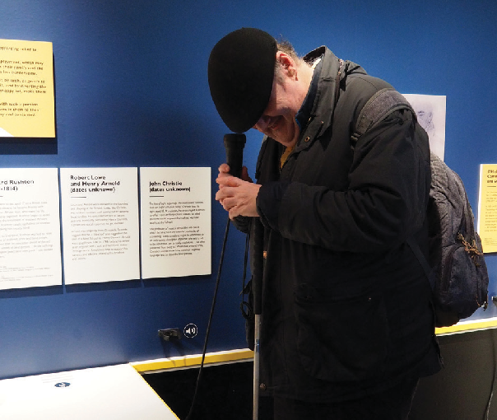
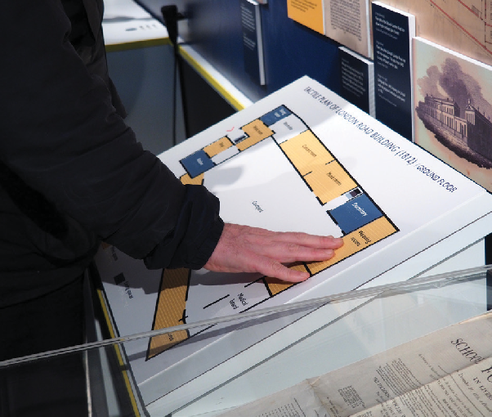

Former student listens to the audio descriptive tour of the exhibition.
Former student explores the tactile and Braille floor plan of his school

Case Studies

Case Study 4:
‘Without Walls: Disability and Innovation in Building Design’ Display at the Victoria and Albert Museum, London

Who was involved: The Victoria and Albert Museum, London, the Accentuate History of Place Curatorial and Project team and Screen South media team.
Supported internally by the V&A Senior Curator of Designs and the Assistant Curator of Designs, as well as the V&A’s in-house design team, print unit,
AV staff, gallery technicians, Access Officer and front of house staff.

What we did: We created the ‘Without Walls: Disability and Innovation in Building Design’ display which told the story of different buildings designed for, with or by disabled people. This traced a progression from a medical model of disability to one where disabled people are the champions, commissioners and creators of their own spaces. The display had three chapters, each devoted to a distinct type of building: the institution, the home and the public realm. Within each chapter, visitors encountered a series of case studies, including the medieval hospital and alms house Maison Dieu in Kent, an early example of a place which cared for disabled people on pilgrimage to Canterbury. Later examples included St Saviour’s Church for the Deaf in Acton, London, the first purpose built church for a deaf congregation; Maggie Davis’ wheelchair accessible home in Nottinghamshire, a pioneering example of how one woman and her husband changed the system to enable them to live independently; and the LightHouse in San Francisco, a centre for visually impaired people partly designed by the blind architect Chris Downey.

One of the built-in features of the space in the V&A is a very long showcase that runs the full length of the gallery. Although this fulfilled its original purpose of enabling historic objects to be displayed securely, it had limited flexibility for incorporating tactile elements, which therefore had to be displayed directly opposite. The display did, however, incorporate a wide range of accessible methods, such as tactile plans of some of the buildings, audio description, audio
described video with BSL and subtitles and a BSL introduction to the entire display.

Impact and lessons learned: With the strong focus on design from the V&A, this display had a powerful story to tell of the ways in which design of buildings and public spaces so rarely considers disabled people. The impact of showcasing disabled people who commissioned and designed their own spaces, alongside buildings designed by non-disabled architects, was profound, highlighting
many themes and ideas that are often hidden during the design process.

With such a serious topic and one for which the main objects on display were architectural plans, and correspondence, the display needed moments of variety and levity to engage audiences. One example was the decision to include a gigantic silver cushion created for one of the buildings featured in the display – Maison à Bordeaux. This house was designed by architecture firm OMA for a client who used
a wheelchair. The large moving platform at its heart, which acted as both a room and an elevator, was later repurposed as a lounge area with a bespoke, oversized cushion. An identical cushion was incorporated into the display creating a fun seating area for visitors as well as helping them to visualise the scale of the original moving platform.

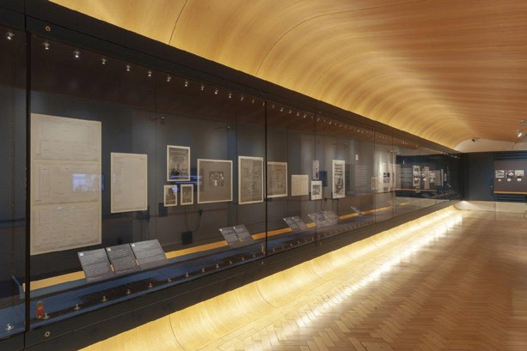

‘Without Walls: Disability and Innovation in Building Design’ Display at the V&A ©Victoria and Albert Museum, London.
Media was used to great effect in the display. An introductory BSL film gave visitors an overview of what to expect in the three chapters – doing it up front was a decision we took based on advice from our disability advisory group, the Heritage Hub, who expressed a preference for BSL on any media but not side-by-side translation of BSL for every text label.
Two in depth films explored the work of architectural access consultant David Bonnett and the experiences of two members of St Saviour’s deaf congregation.
The latter was edited to include audio description of the imagery being shown, as well as BSL and captions. A final media piece showed original slides from the personal archive of Maggie Davis, herself disabled and a pioneering campaigner for the right to independent living, overlaid with her oral history which was also captioned and interpreted with BSL.

The display’s conclusion, featuring the work of disabled architect Chris Downey and disabled building consultant and designer David Bonnett, showed that there is hope for a fully accessible future, one in which design for disabled people simply becomes ‘universal design’ with features that benefit all people. Anecdotal feedback on the display, especially from disabled visitors, suggests they were pleased to find the topic explored in such depth. However, many of them made suggestions as to how to improve the accessibility of the design. Key comments included: making it easier to find from the main entrance (the
V&A does not signpost these kind of free, changing displays) and making front of house staff more aware of the display (not all of the V&A’s many employees were aware of the display). Additionally, visually impaired people wanted more tactile displays and guidance on how to use the audio description as finding the first point was difficult without guidance.

Credits

Thank you! By reading this toolkit you have made the first step in making your exhibitions, museums and spaces more accessible for all.

Museums and heritage organisations hold an important societal role in capturing, creating and interpreting the world, and this guide will help you take responsibility to make positive changes to ensure that the history of everyone is represented.

We would love to know how you use this guide or how you have made your activities accessible and worked with deaf and disabled young people. Let us know by tweeting us at:
@H_O_P

Feel free to share this toolkit with other organisations you think might find this useful (museum or non-museum!). If you would like a copy of the guide in an alternative format, please get in touch with us at Screen South:
Accentuate History of Place Screen South
The Wedge
75-81 Tontine Street Folkestone
CT20 1JR
Tel: 01303 259777

Find out more about the History of Place project and visit historyof.place

With special thanks to our contributors, Esther Fox, Grace Swordy, Kerry Massheder-Rigby, Katie Ann Smith, Paul Homer, Jo Nolan, Charlotte Kingston, Olivia Horsfall-Turner, Karen MacDonald, Catherine Johnson, Kay Jones and all the volunteers, workshop participants and organisations who contributed their thoughts and experiences over the course of the History of Place project.

Additional thanks is given to the Heritage Lottery Fund for their support and advice. Without this, History of Place would not have happened.

Illustrations by Beatrice Baumgartner-Cohen www.cohenbaum.com

This toolkit was funded by the Heritage Lottery Fund and our sponsors. It was developed and delivered by Accentuate History of Place, part of Screen South

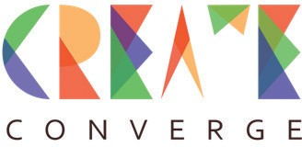
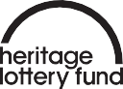

With particular thanks to our supporters of this toolkit:

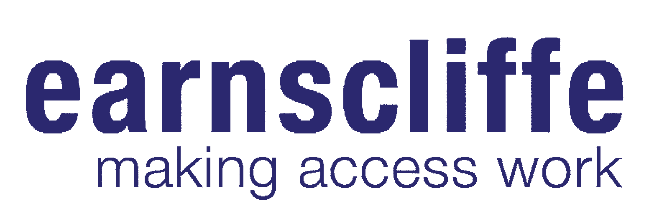
Jayne Earnscliffe: Making Access Work, www.earnscliffe.co.uk

With a unique specialism in inclusive exhibition design Jayne has embedded high standards of accessibility across a vast client portfolio that includes the V&A, British Museum, National Maritime Museum, Science Museum and Grand Egyptian Museum, Cairo. Passionate about inclusive design, her pragmatic, non-prescriptive, creative approach places people at the heart of the design process.

Tactile Studio, www.tactilestudio.eu

We are a design studio specialised in inclusive art mediation. We partner with some of Europe’s most renowned museums including the Louvre, the Deutsches Museum and avant-garde national projects such as History of Places. More than three hundred museums and heritage sites have already entrusted their collections to our multi-sensory expertise and have reached new audiences. Let’s meet!

The Hub, www.thehublimited.co.uk

The Hub is a specialist fit-out contractor that has delivered high quality projects for national and independent museums for over a decade. With experience in delivering projects from construction to fit-out, The Hub deliver turnkey projects collaboratively to ensure that the expectations of our clients and their visitors are met.

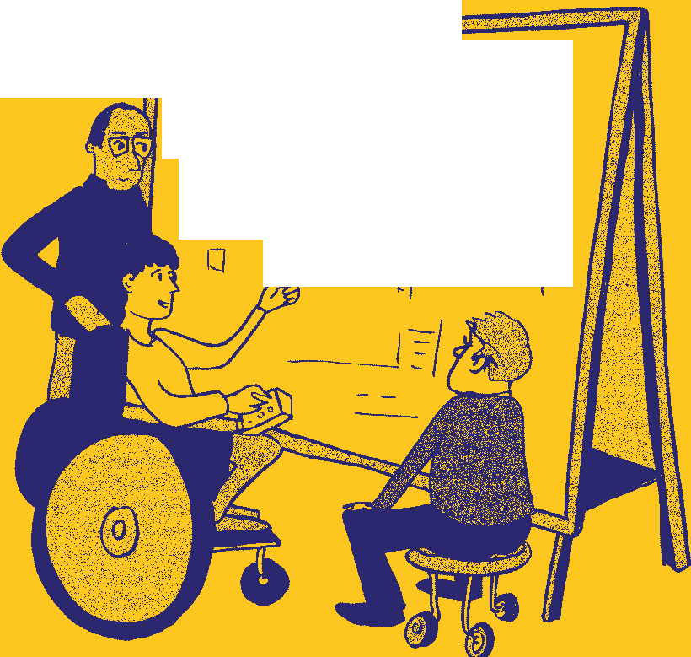
' I ° _II cf}
- I

