Accentuate History of Place
Digital media plan

SURFACE IMPRESSSION
11a Jew St • Brighton • BN1 1UT • www.surfaceimpression.digital
info@surfaceimpression.com • 01273 958600

The ‘History of Place’ Project

The digital elements of the ‘Accentuate History of Place’ project will link closely with other (non digital) project deliverables including:

- Participatory activities (workshops, creative production, heritage volunteering)
- Local exhibitions - which will come together into a national exhibition in Bristol ( M-Shed) The Museum of Liverpool and the V&A Museum (tbc).
- Involvement of 8 key sites, chosen for a variety of venue types, geographic spread and associated history of different disabled people and groups
- The Accentuate website – which will be central to everything and include different sections for each group and site.

The eight places to be covered in the project are:
- Maison Dieu, Ospringe, Kent
- Liverpool School for the Indigent Blind, Liverpool
- The Royal School for Deaf Children, Margate, Kent
- Chiswick House, London
- St Saviour’s Church, Acton, London
- The Guild of the Brave Poor Things, Bristol
- Grove Road Housing Scheme, Sutton in Ashfield, Nottinghamshire
- Langdon Down Centre, Normansfield, Middlesex

Target audience

Research that Accentuate has carried out with the Heritage Hub has identified that the target audience for the project will include:

- Those connected with heritage but no connection to disability
- Those who don’t connect with disability or heritage
- Professionals who connect to disability or culture
- Disabled people who are connected to disability cultural history but not disability
- Disabled people or family members who have no connection to cultural activities. Parents of disabled children who don’t connect with disability culture/politics including parents of disabled children.

There will also be audiences of people who are local to the 8 partner sites and those with strong family history and local history interests.

Digital outputs

The project will produce a set of interconnected digital outputs, these will be a key point of interaction with the audiences and will consist of:
- A website
- Games
- Mobile tours
- Digital presentations within a physical exhibition
- Social media

Aligning the different aspects of the project with the digital media outputs

The activities proposed in the Part 1 application to HLF include:
- Community heritage workshops
- Oral history recordings
- Research into the eight sites
- A touring heritage exhibition
- Training for heritage event organisers/historic tour guides and volunteers
- Workshops with young people to produce documentary films - with a focus on the creative process.
- Workshops with young people to produce Games - with the focus on the making of the game.

We believe this programme can be optimised to help produce the form and content of the digital outputs most effectively, for example:

- The website is used as the “medium” of the community heritage workshops, research aspects and oral history recording
- Using the mobile tours as a medium for heritage event organisers/historic tour guides and volunteers
- The film elements, mobile tours concept and game elements are overlapped by shifting the game concept from a computer-based, flash-style game to a mobile-based, “real world scenario” game.
- Digital elements of the exhibition (films, interactives etc) should be created as dual purpose items to be also used in the other digital outputs as appropriate

Priorities

The project outputs will be created with the following principles:

- Accessibility must be of a very high standard, because of the nature of the topic and the expected audiences, the project needs to demonstrate best practice in this regard.
- The themes and content of the project will create an engaging picture of national disability heritage; revealing the hidden histories of the lives of disabled people from the Middle Ages to the late 20th Century using the places of interest as the key to unlock narratives.
- “Real world” and digital activities will be integrated so that participants can engage with the project in multiple contexts, via the times, places and devices that are most appropriate.

A digital strategy

Digital media will have a number of roles to play within the project, these will include:

- Present material from the archive in a number of formats (image, text, video, audio) to different audience groups (people in formal and informal education, the general public, academics and heritage professionals)
- Contextualise the history of disability and its relationship with the 8 venues using engaging interpretation material
- Engage online and offline visitors (local people, children and young people, and tourists) to venues and surrounding areas with trails and interpretation delivered directly to their own handheld devices (smartphones / tablets)
- Attract visitors to travelling exhibition at different venues (eg Bristol and London).
- Encourage people to share the project resources to their own networks of friends or colleagues

The “offer” of this digital activity can be conceptually organized into “layers”:

The presentation layer: this is the level at which the audience interacts with the content via main devices at their disposal. These might be:
- An app or mobile website on their own smartphone or tablet
- A web browser on a desktop or laptop computer – using the web at home, at work or a place of learning. In this case it might be to research items from the archive, to plan a visit to publicly accessible venues or to explore the stories of the 8 venues and disability history remotely.

Social interaction at the presentation layer varies – for example using the resources via a desktop computer is generally a private, one to one interaction, whereas the use of a smartphone on a tour is very often a shared experience between two to four people as they follow the route.

We can also include social media as an aspect of the presentation layer – although it relates to the infrastructure layer differently since it is made available by third parties, it can be treated as part of the same process in terms of production.

The infrastructure layer: this is where all the systems that package and deliver content to the presentation layer are located. In this case we would include:
- A web content management system (CMS) – to be the element where much of the project’s content is uploaded and edited. It will also “pull together” the other elements of the digital offer into a coherent navigation system and a unified design style (visual identity).
- A mapping platform – a system to handle the bringing together of maps and content – for example points along a trail or archive maps and plans and their locations.
- An online directory of archive records - in this case a means to reference documents, maps, photographs or other archival sources that have been used to illustrate the topic, rather than a new digital archive / catalogue. This will, of course, signpost readers to where they can access archive material themselves, using online or offline sources.
- There may be a need for some bespoke or off-the-shelf plugins, modules or code to help integrate these aspects into a coherent whole for the web visitor.

The infrastructure layer also consists of the technical infrastructure to run the systems, as well as the systems themselves. This includes one or more web server, domain names and possibly other aspects of IT provision.

The content layer: this is the material that the project has generated for its audiences, represented as pure “content” (without design, or functionality). In essence the content is the “input” that the infrastructure layer repackages to create the “output” at the presentation layer. Content will include:
- The pages of the website
- Trails and tours
- Interpretation content – image, text, audio & video to help with the exposition of the narrative
- “Archive” records – items digitized and/or transcribed and presented via the site or online maps
- The games

Digital skills in the project team

Many parts of the heritage sector is moving towards a “digital first” strategy, or at least a strategy that puts digital media production close the heart of principal activities. By incorporating digital production requirements as part of job descriptions and volunteer tasks and by making all contributors aware of how their work helps to build digital connections with audience members, then the project’s activities become aligned towards creating better quality and more plentiful digital resources.

Below are some guiding headings taken from the Tate “Digital Transformations” strategy that would serve well for this project. See http://www.tate.org.uk/about/projects/digital-transformation for more details. We’ve added some explanations below each heading.

- Audience-centred and insight-driven
The team will create material with the audiences identified in the activity plan (and reviewed at intervals along the project’s lifespan). Insights will be identified from monitoring/measurement of activity, from user feedback/testing and from partnerships/suppliers/events.
- Evaluated and enhanced
An editorial process will be established to make sure contributions are fact-checked and copy-edited. Enhancement includes activities such as improving the descriptions / transcriptions of archive records or adding illustrative images to narratives.
- Well designed and architected
Design and brand will be established by your design suppliers, but its day to day implementation will be the teams responsibility, following their brand guidelines. “Architected” refers to the structure of the site (or catalogue, maps and other outputs), and the hierarchy of information within each page or screen. This will be established collaboratively in the design process, but maintained by the team.
- Distributed across multiple platforms
As shown above, the integration of content and design across multiple platforms is part of the core concept for the digital activity. For example, an archive record, complete with scanned document, can illustrate an article on the site, appear on the map, be tweeted or just presented well on a catalogue search.
- Open and shareable
HLF guidance encourages the distribution of resources under a Creative Commons (CC) license, encouraging reuse of material in different, creative ways by people all over the world. Some rights can still be retained under CC and it would be a good idea to see how this fits with the project plan.
- Sustainable and scalable
This also is in accordance with HLF guidance. Planning for the long-term future of the project will mean the resources as a whole perform much better and deliver more cultural value. Scalable refers to the ability of the systems to expand to contain more content or to be able to cope with more usage – these should also be part of the project briefs to suppliers.
- The product of collaborative work
This is one of the most important aspects of the project that also applies to the digital elements. The more collaborative the project can be, the more coherent the results will be for the audience as well as the team. The project team, interpretation designers, web / app developers, Accentuate, the 8 project partners and others will all be contributing to the project, but if the project management process brings people together in appropriate combinations at key creative moments (such as content planning, creation of interpretation, branding and overall design, user-testing, quality control) then the products will be enhanced. However, collaboration does not need to mean constant meetings of large groups of suppliers and stakeholders, or “design by committee” – that would result in higher costs and a lesser outcome. There are “agile” techniques of project management that seek to reduce these costs and improve quality and this can be written into the project briefs.

The nature of the work will be mainly focused on content, but knowledge of the processes and some skills in creating, managing and using digital assets should be part of the project team job descriptions (and included in the recruitment material). Some training will also be required – and this can be written into the briefs for the suppliers.

The digital project team will work with the Accentuate team, that will include the Head of Accentuate Programme, the Project Manager and two Project Coordinators. These professionals will all have day to day digital production responsibilities as described above, but we believe the editorial quality of the project will be enhanced by including a content editor (on a freelance basis to keep costs down).

The Digital Content Editor will have the following tasks

- To work with suppliers and team to set the tone and house style for the project
- To advise the team (and volunteers) at Accentuate on an ongoing basis
- To maintain focus on the audience
- To edit content (web pages, tour points of interest, social media posts etc) from the material developed as part of the project (from historical research, community engagement, expert contribution and more) so that it adheres to the house style and is interesting and engaging for the audience.
- To edit content contributed by suppliers, team and volunteers
- To have a broad technical understanding of different digital media outputs, including their potential and limits

This person will have experience in heritage/cultural sector production and a broad range of understanding of digital media. They will be used to coordinating suppliers, stakeholder and project team and therefore be a skilled communicator. This person will have responsibility for the overall content quality and be able to control how content is disseminated across platforms and sites, and needs a broad technical understanding of the digital requirements of the project.

A summary of the other roles in the production of digital media for the project are:

Accentuate project team | The project team of Project Manager, Project Archivist and Project Coordinators. Chief roles in digital media will be content production, client-side project management and quality control.
Web development company | The designers and developers of the web-based aspects of the project, including integration of the various platforms.
App / Game developer | An app-development specialist. The web design company may include this service or it could be provided as a stand-alone contract.
Access consultant and user testing facilitator | To create access guidelines and manage access review points. To organize and carry out access user testing and evaluation
Graphic and brand designer | The designers of the project “brand” to be reused across the project. The brand designer is important as they will set the ethos of the project and create brand guidelines and to pin down the look and feel of the project. The design and brand will apply project wide and will be integrated within the exhibition as well as reflected within the website and design of all associated elements. Note: This supplier could be employed for this role as an early stage in the exhibition design contract.
Film-maker | To work with young people to create film content to appear across the different platforms (website, games, tours)
Creative facilitator | To plan and facilitate workshops with young people to develop ideas and material for the game, website and tours. The briefs for the games and films workshops will need to be pinned down in detail to ensure that they achieve clear outputs.

Outputs

1. Website

Below is an outline site structure that could be used to organise the website. This content approach leads with the eight places themselves, each of which would act as a hub to deeper content articles – some specific to the place, others covering topics that span across places. In recognition of this, it’s suggested that there would also be a top level section to give access to all “stories” via a thematic, rather than geographical route. The site will also need to promote the events that are being held (including workshops and the exhibitions) and a section that covers the more functional aspects of the project (“About”) will also be required.

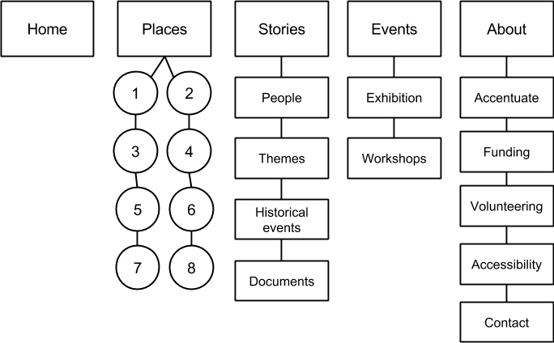

Aspect | Discussion/approach
Audience | Accentuate has identified key audiences for the project:  · Those connected with heritage but no connection to disability  · Those who don’t connect with disability or heritage  · Professionals who connect to disability or culture  · Disabled people who are connected to disability cultural history but not disability  · Disabled people or family members with no connection to cultural activities, or parents of disabled children who don’t connect with disability culture/politics including parents of disabled children.  There will also be audiences of people who are local to the sites that are involved and those with strong family history and local history interests.  Estimated numbers: climbing to 2000 – 5000 unique visitors per month during the span of the project
Form | - The site will provide an online identity for the project and act as a hub to allow visitors to discover the various facets of the project  - Navigation should be multi-faceted, allowing visitors to explore the content by the contexts or routes that interest them, rather than through a strict hierarchy  - Design should be fully integrated with the design style used for interpretation on-site and at the travelling exhibition
Content | As described above, the website content roughly divided into the following main areas:  - Descriptions of the 8 places  - Key themes common to all places  - Events running throughout the project  - Supporting information about the project  Content pages can contain the following:  - Timelines showing the periods and events covered by all of the 8 sites and within each site  - Maps of all sites and each site  - People profiles of figures associated with each site  - A portal to the games and tours  - Promotion of the exhibition, events and workshops  Themes might include:  - Agency of disabled people in design of buildings  - Education and skills  - Faith, Religion, Philanthropy  - Power relationships between disability, place, charity and other contexts  - Oral history  - Architecture  Articles will be supported by historical documents - such as records, resident lists, photographs, plans, maps, diaries, letters, audio recordings or film. These will be indexed on the website so that they can be searched by visitors, but the site will not act as an archive in its own right - instead it will signpost to the archives and repositories where the items were found. This will help promote the archives, libraries and museums (and heritage organisations such as English Heritage) that relate to the topics concerned.  Visitors to the site will be able to contribute their own stories and scans of archive finds or historical artefacts. The submission system can be built around the commenting infrastructure provided by most content management systems so that a standard moderation process can be used (we would suggest post-moderation to reduce the barriers to contribution). Using strong calls to action on thematic pages, and encouraging people to contribute material to the site during workshops (and other real world activities) will greatly increase the volume and quality of material submitted.
Technical delivery | - HLF encourages use of an Open Source platform (we agree)  - Wordpress would be a typical open source content management system used for this scale of project.  - The site will sit separately from the Accentuate site but will link to and from it at many points. Some brand assets will be shared across both websites. Keeping the sites separate will reduce the training overhead and day to day management of the project.
Suppliers | - Graphic design: Overall brand / look and feel will be a separate commission, perhaps tied in with the exhibition design  - Interface design & build: Web design/development company to be commissioned  - Content: Accentuate, interpretation provider, venues and partners  - Hosting: The website developer, Accentuate or a 3rd party hosting provider.  - Support: 10yrs from commissioned developer
Sustainability | - Requirements for support should be built into the website development brief. The facilities and usage patterns of the internet will change considerably during the lifespan of the project, and an ongoing relationship with the suppliers is necessary in order to maintain the site’s performance, both editorially and technically.  - Using an open source content management platform (such as Wordpress or Drupal) will mean you are not tied to one supplier for the duration of the project. There are many developers who have the skills to maintain and extend these technical platforms.  - Building in regular monitoring of website performance (via the Google Analytics web statistics system or similar tool) plus regular reviews of content will ensure a high quality result over the longer term.
Timetable | Year 1: “Starter” site with overall project info and events listing  Year 2: Release of main features  Year 3: Consolidate with deeper content derived from main project
Risks / mitigation | - Project timeline slips  Require a reasonably detailed project management plan as part of supplier proposals. Hold regular (real or virtual) meetings with suppliers for project updates. Make sure team supplies content materials on time. Build in some flexibility into timescales.  - Breakdown in relationship with supplier(s)  Specify an open source platform so suppliers can be changed if need be. Maintaining regular contact reduces risk of relationship degradation.  - Hacking / technical failure  Choose a high quality hosting provider. User “cloud” hosting which has greater backup systems and infrastructure resilience. Establish your own backup regime.  - Accessibility issues  To ensure the site reaches a very high standard of accessibility, we recommend that quality control from a third party supplier (a digital access consultant) and user testing is incorporated into the project. To this end we have separated this out as another deliverable below.

Useful examples:

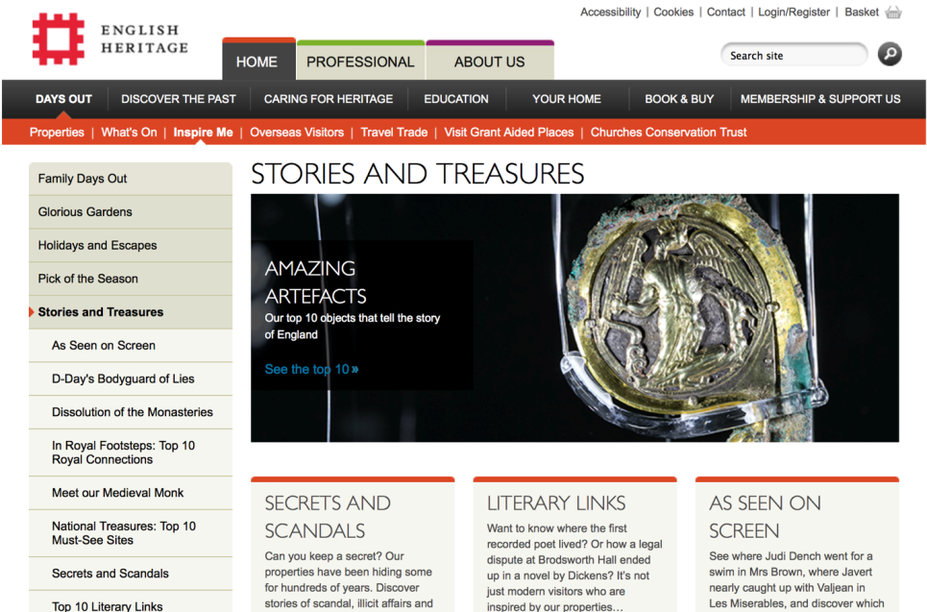
English Heritage – stories and treasures
http://is.gd/DkemMU

This section of the English Heritage website demonstrates well-written, engaging thematic content that cuts across the “place”-based information that makes up the bulk of their pages.

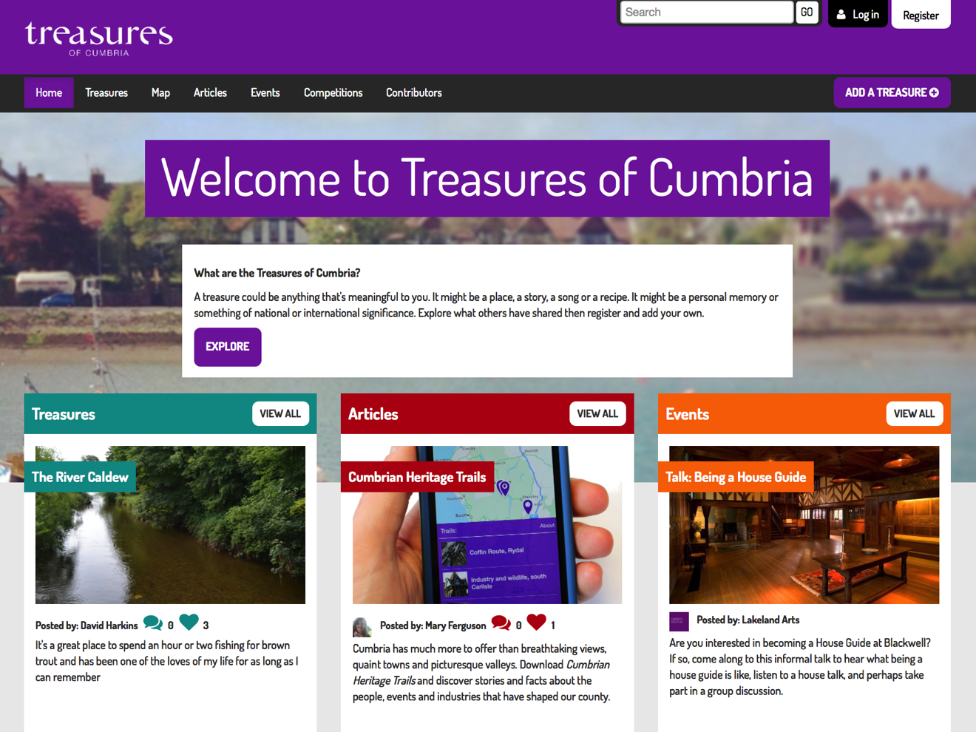
Treasures of Cumbria
http://www.treasuresofcumbria.org.uk

This site takes a broad approach to the combination of heritage and place. By offering a mix of heritage and “pop” interest items, they can explore many aspects of the cultural life of Cumbria. Note the promotion of their trails app in this screen shot.

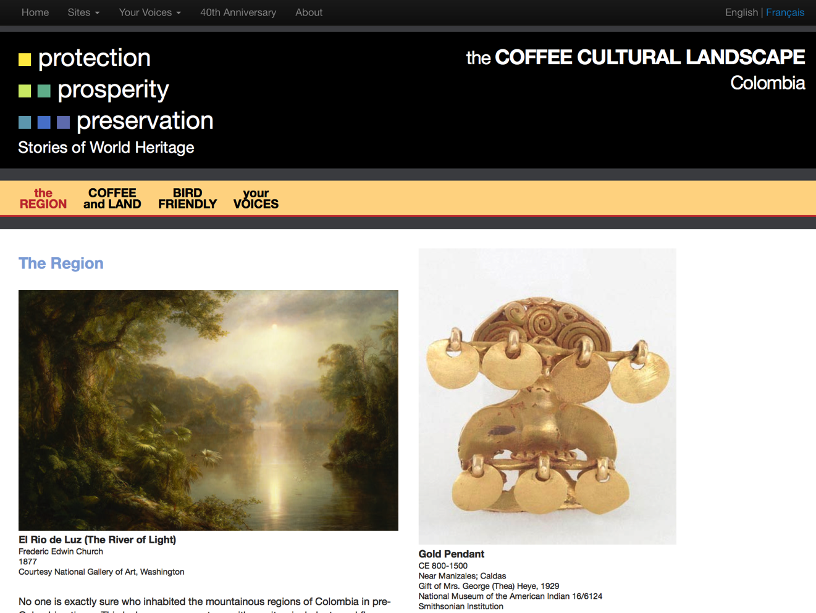
Smithsonian World Heritage
http://worldheritage.si.edu/

This example wasn’t chosen for its design; which could be improved greatly, but it does represent a good approach to exploring the nature of heritage at a series of places. Note how they relate museum objects and archive documents to the content and how the thematic stories have been created.

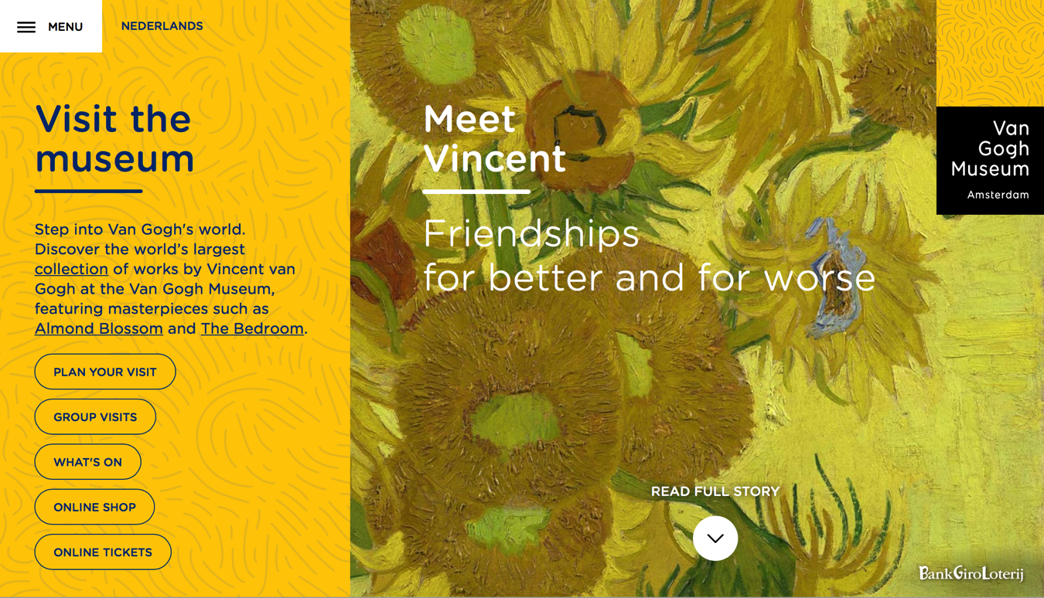
Van Gogh Museum
http://www.vangoghmuseum.nl/en

The Van Gogh Museum has taken a new approach to the presentation of heritage narratives online. As well as the normal information found within museum sites (visitor info, events, collections descriptions etc) there is a strong narrative component that site users are invited to dive into from the home page. The stories avoid the catalogue-like construction of most online exhibitions, instead using short messages and quotes, accompanied by archive images and reproductions of paintings to lead the reader through a theme. Presented in a single, scrolling page, the effect is similar to following a narrative thread around a physical exhibition.

2. Accessibility quality control
The digital outputs of the project need to be as accessible as possible, to enable people with different impairments and situations to engage with the topic and its content. To this end, we recommend that the quality control for accessibility (including user-testing) is treated as a separate element of the project, and a consultancy and volunteer testers recruited to help fulfil this aspect. The access consultant would be able to benefit from the involvement of Heritage Hub members for advice, and some members may be involved in access user testing.

Aspect | Discussion/approach
Audience | Consult with the project steering group and the target audience during creation of the digital elements, and to ensure user centred design. Create access guidelines for the content creators to ensure we define accessibility and that everyone has the same guide to making the content accessible. Carry out access user testing with the target audience (audience as above).
Form | Regular access review points with project steering group.  Consultancy with target audiences at key project stages (in focus groups and interviews).  Access user testing with target audiences.  Produce report and recommendations to feed back to the development team at each stage of consultancy during the project development.
Content | Access user testing will follow this test structure:  - Review paper-based principles and wireframes to anticipate access issues and review different access journey viewpoints before the build - run focus group to review wireframes with paper based plans and cover different access perspectives.  - Demo early test version to client/access group and integrate feedback into development.  - During the build - test Beta version with 1 test participant using assistive technology and 1 in-house developer - with reference to a test script that will include key functions of the site/app. She will pass test feedback and recommended changes back to the development team. As well as overall usability and accessibility we will test the following aspects: Usability, Quality assurance, Platform, Browser.  - Test later test version with range of assistive technology users and participants with variety of access needs, including:  - 1 screen reader user  - 1 screen magnifier user  - 1 BSL user  - VI tablet or Smartphone user with access features enabled  - 1 user with mobility impairment  Accessibility standards and best practice will be taken into account. The most appropriate guidance for this project (to be included in all project briefs) is the Web Content Accessibility Guidelines 2.0 (WCAG 2.0). See http://www.w3.org/WAI/intro/wcag  WCAG 2.0 includes a useful guide for producers and developers that helps maintain accessibility at all stages of production. See http://www.w3.org/WAI/WCAG20/quickref/ . However, it should be stressed that meeting a standard via a checklist is a useful tool, but does not mean the digital product is actually accessible. Experience, expertise and above all user-testing are also required.
Technical delivery | Findings from the testing will need to be incorporated into the digital outputs by the various suppliers - so all briefs will need to require that resources be set aside for this work.
Suppliers | Access consultants  Volunteer testers  Hub members - to refer to for advice and include as test participants
Management | Accentuate, access consultant

3. Game and trails

The strongest idea for the gaming aspect of the project that has emerged in the development process is to create a “real world” game (sometimes also known as “Alternate reality games”). These are games played out in the real world, by following instructions and scenarios distributed to the player via their mobile phones or tablets. The advantages of this approach and form of game are:
- It moves the focus of the game from a rectangle on-screen to the eight places at the heart of the overall project
- Film, web content, archive research and other products of the project can easily be incorporated into the game
- Efficiencies can be made in combining elements of the film production workshops and games production workshops
- It is easier to make a game that is predominantly played out in the imagination accessible to people with different impairments. For example, the same information, crucial to a stage in the gameplay, can be delivered by film, by audio or via text. If this awareness of accessibility is built into the production requirements, the output will be very comprehensive.
- It will be possible to reach a higher quality level at a lower cost, if the game relies on staging and narrative techniques rather than cutting-edge graphics.
- The films that are created will reflect the four local areas where the workshops will be held and a total of four different films will be created (one for each site).

The game will mainly be delivered through mobile devices (phones and tablets). The trails will also be delivered through mobile devices. Therefore we believe it will make sense to deliver both aspects through the same branding, platform and presentation technology. There will be options for people to follow a straight trail or a game version to explore the content, depending on what they prefer. 4 different games will be created (possibly using the same engine but using different content).

We would suggest that the game also has an “armchair” mode so that the content can be accessed at home or away from the sites of interest.

Some example real world games are:
- Ingress - https://play.google.com/store/apps/details?id=com.nianticproject.ingress
- A Machine to See With - http://www.blasttheory.co.uk/projects/a-machine-to-see-with/
- VuHunt - https://play.google.com/store/apps/details?id=com.vuhunt&hl=e

The choice of technology for mobile interaction is currently:
- Via mobile-optimised websites - web pages that can adapt their dimensions and presentation to different devices, and can access some functions of the hardware (eg GPS).
- Via a “native” app - stand-alone programmes that run on Apple and Android devices and use the code and systems provided by the operating system manufacturers.

Both approaches have advantages and disadvantages, some of which are described here:

Platform | Advantages | Disadvantages
Mobile-optimised websites | - Cheaper to create  - Fast to edit  - Can be accessed without needing to download first  - Will run on more unpopular devices (eg Windows phones)  - Large pool of potential developers available | - Can run very slowly  - Requires a constant live connection to the internet  - Cannot use some features of the devices and quality can be poor on other functionality (eg GPS)
Native apps | - Runs fast and interaction is very responsive  - Can reach new audiences via app stores  - Can use features of devices (camera, accelerometer, location etc)  - Can preload content and run without internet connectivity | - More expensive (typically)  - Long publishing process  - Availability needs to be promoted more as search engine access is low  - Harder to update software and content

Development and commissioning of the games
The aim is to create a game genuinely inspired and informed by participation by young people but aimed at general audience. A key issue to deal with will be balancing the creative freedom afforded to the participating young people while achieving production values high enough to have appeal to all potential players of the game.

We propose that a creative practitioner will plan and facilitate participative workshops with young people in four different areas, with outputs including film clips (and /or briefs for subsequent filming to be coordinated with the film maker), ideas and other material, from which clear briefs including the structure of game play can be developed, followed by production and testing of the actual games with a contracted games developer.

The intention is to develop games involving real participation with real spaces (rather than a purely on-screen experience) as this approach seems more appropriate for this project which focuses on sense of place, and also because a real-world experience is likely to be less ‘contrived’ than an on-screen interaction, and is also likely to have more long term impact.

As noted elsewhere, there are efficiencies to be made by combining trails, documentary film-making and game aspects of the project. There will be overlap in the workshops, in production and in the media outputs for all of these activities.

Suggested process

- Recruit a creative facilitator (CF)
- Select games developer
  - One option is to appoint the games developer early enough for them to participate in the creative process while the workshops and content generation (including filming) are taking place. This should improve the quality of the final products. For example they can help filter out or amend ideas being taken forward that will not ultimately be viable. It also has the benefit that the initial load on them as a supplier will be less, and ramp up once the game briefs have been agreed.
  - There are arguments for leaving selection of the game developer until clear briefs have been defined, as this might affect which developer should be selected. Also that if the developer is on board from the beginning, they may steer the focus of the games towards products that are easier to produce or favour their own style.
  - In either case, it will be important for the Digital Content Editor and the Accentuate Project Manager to have sufficient experience to guide the creative process effectively, avoiding the above pitfalls.
- In consultation with the team, the Creative facilitator (CF) establishes contact with venues and makes initial assessment of those most promising to work at.
- CF then works up a more detailed framework for development of the game(s) including managing the participation of YP. This will include clear statements of any known constraints (for example that the end results must appeal to a more general audience, that the game(s) will focusing on user participation in real space not just on the screen, that the YP will have a creative input but overall editorial control rests with the Accentuate team, any obvious implications of the overall budget and so on), notes on initial ideas for games etc.
- Drawing on this, they then develop a ‘job description’ for the YP who will participate, focusing on their responsibilities and also on safeguarding, as well as outline notes on each of the venues likely to be involved etc.
- CF identifies a suitable group of YP to work with and gets their agreement to the above, establishing a firm contract with them.
- CF liaises with the filmmaker to agree that they will film during the four main workshops and/or films afterwards based on ideas arising from them.
- CF facilitates workshops with YP, monitoring ideas and assets arising.
- The film maker takes on concepts to the film workshop participants and these elements are created. Attention is paid to making viable audio and text alternatives to each part of the narrative.
- The games developer creates a framework to deliver the content assets and to lead the player through the stages of the game (eg missions, geocached “objects”, achievements, roles etc)
- The game is tested with users and refined
- The game is published

Aspect | Discussion/approach
Audience | The project team has expressed an interest in using digital games and trails as a means to express the link between the historical context and place for the audience. The trails and games would appeal to younger audiences.  Use of the resource would most likely divide into two audience groups –  - Remote: those that access the map from work or home (desktop/laptop computer-based browsing for research or hobby)  - On-site: those that use the location services and mapping to follow a trail while making a physical visit.  Estimated numbers: 500 to 5000 engaged users over lifespan of the project, depending on approach
Form | The two audiences may need to be served by two form factors (although the platform “behind” these could be the same. These are:  Online map – Google Maps – style interface with placemarks (possibly arranged into thematic layers). The placemarks can represent stories, digitized documents, physical features/buildings in the landscape etc)  Smartphone app or mobile site (we’ll call both possibilities an “app”) - a handheld user experience that delivers trails directly to people as they follow them  The idea would be to take games beyond the screen, and to integrate into a real world experience and we’d involve young people from different venues to bring this to life, working with a creative facilitator across the selected partner venues. The developers would work alongside the creative facilitator and link up with different groups of young people to develop, polish and test the product.  Trails will be available to download so users can refer to them before, during or after a visit. Creating mobile accessible trails means that they will be widely available and flexible to work across different platforms. If they are available as an app it means that they can work independent of any network. Some of the content will also be made available from the website.
Content | Online map: Themes can also be developed in the site using and extending the interpretation material developed for the exhibition and. For example, a digitized historical map can be overlaid over the contemporary, interactive map and “placemarks” used to indicated where further interpretation is available. So a site visitor can click on placemarks and a panel will appear that includes photographs, text, other archive items, video or audio to further explore the historical context of “place”.  App /Mobile website: Narrative trails that act as interpretation as people walk along. Additionally, written directions will be included (much like existing guided walks). Maps and waypoints will sit alongside illustrations, photos and text which can be enhanced with audio or short video clips. The device will geolocate the user so they can see where they are on the trail and be served appropriate content.  Because the venues vary in terms of access to the public, there will be a variety of content for different venues:  - Tours at some  - Games at some  - Some might start as a trail then lead into a game  4 of the 8 sites have been identified as being suitable for gaming/trails content:  - Maison Dieu, Ospringe, e.g. do you know there were disabled pilgrims on pilgrimages? Thematic links to Canterbury Tales.  - Liverpool School for the Indigent Blind, Liverpool, potential for gaming  - 1892 Chiswick House, London, lends itself to a tour onsite (unlike other virtual tours). Potential for gaming e.g. download audio tour referring to modern poetry  - The Guild of the Brave Poor Things, Bristol, potential for gaming  We can use ‘soundscapes’ of audio to present images and sounds within interiors or exteriors using a relatively new map interactive technique which strings together some of the content already being produced. We can layer sound effects and text and place them over a map created of photos of the place joined together (in a method similar to StreetView) - http://vimeo.com/101599212  This combines different types of content to create a greater 'multi-sensory' effect and might include descriptions, music, poetry, bird song and extra information available to visitors on the site. This would greatly increase overall access as it means that visitors are not required to visit a location but can experience it remotely. It also greatly increases the accessibility of all the content being created as it will be available online, e.g. at Chiswick House (where they’ve almost deleted the previous use of the house as a private asylum) we might reinterpret the whole site as an asylum and from the residents’ perspective.
Technical delivery | The first aspect to establish is the mapping platform, as this will include the store of geo-located content and the means to place items onto maps in a style that integrates well with the main site and project as a whole.  From there narrative themes will be developed, and these will be displayed through the map interface. The system will also be used to supply content to the app/mobile web site.  The current choice of technology for the trails is between creating an App (typically for Apple iOS devices such as iPads and iPhones as well as Android-based devices) or creating a mobile optimised web site (sometimes known as a mobile web app). A mobile web app will be cheaper to produce, and can be integrated with the main website, but will suffer from poor performance if mobile data connectivity is patchy in the relevant areas. Some visitors from overseas may not wish to use the product as they will fear data roaming charges. A “native” app will be costlier to implement, and harder to maintain, but will be capable of avoiding data connectivity issues and will have more precise GPS location facilities. It will also open up new marketing channels on the Apple App store and Google Play, which are often used by visitors as a means to check out “destinations”.
Suppliers | Online mapping: Google, Open StreetMap, Mapbox  Development: website developer or specialist app developer  Integration: Web design/development company to be commissioned.  Content: Accentuate, partners  Hosting:  Support: Web developer
Timetable | Year 1: Development of platform and geolocated content  Year 2: Roll out of functionality/content to integrated website  Year 3: Further development of trails and map-based archive/narrative material
Management | Accentuate team, Website/App developer

Useful examples:

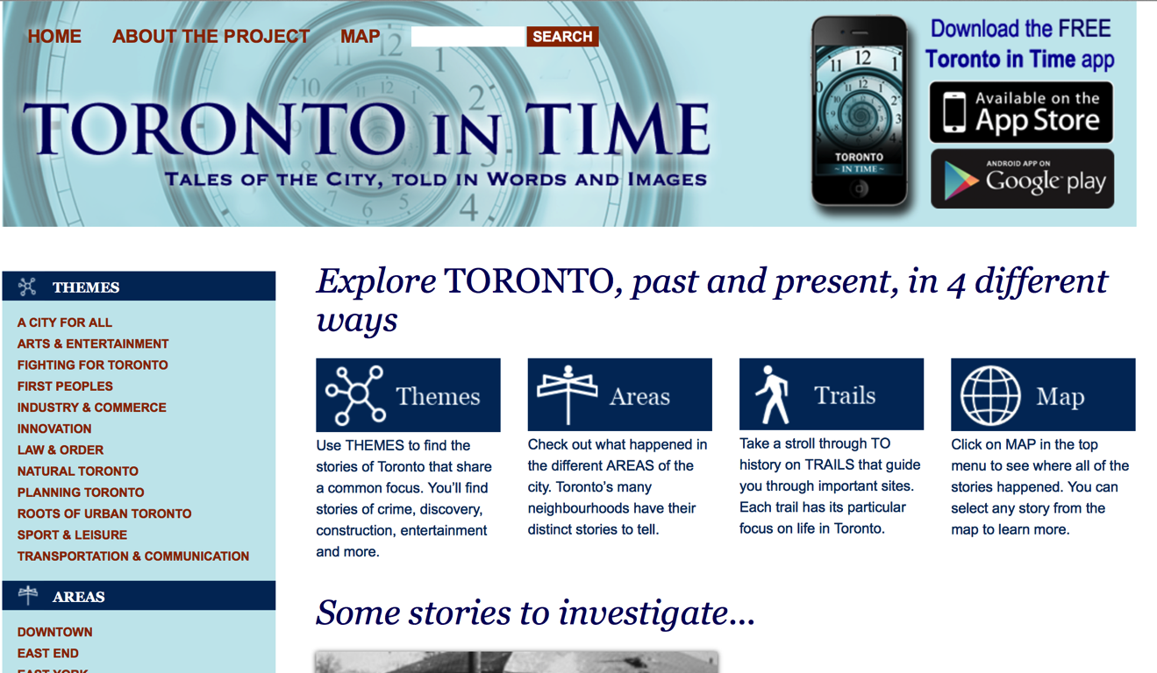
Toronto in Time
http://citiesintime.ca/toronto/

This trails-based app also has a content-rich website with an interesting selection of themes. The way the producers have structured the content helps make understanding a diverse range of material easier to access and comprehend.

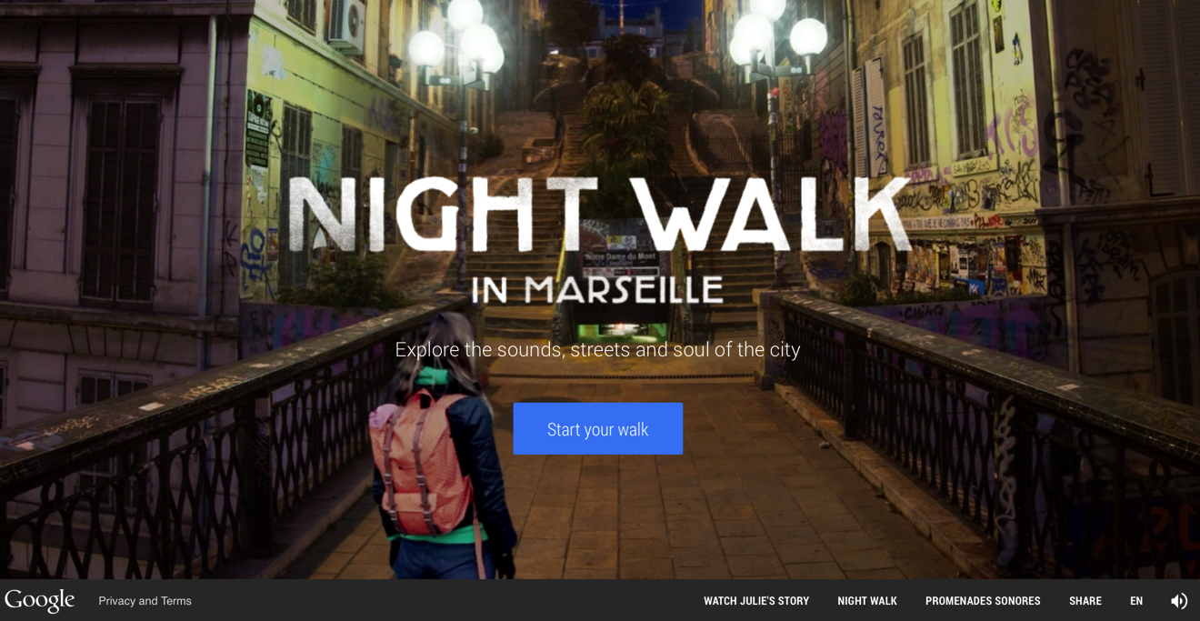
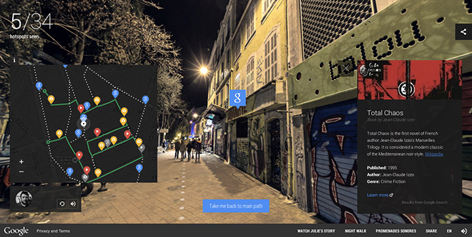

Night Walk in Marseille
https://nightwalk.withgoogle.com

Google has taken the standard infrastructure of their maps and streetview services and reused and recombined them to explore Marseille in a sensory, highly personal narrative. Following the trail, one hears the ambient sounds of the city (using special audio that gives the impression of space – as you turn your point of view, the source of the sound appears to move relative to you). One also encounters different characters and can discover embedded photos, videos and other elements. Although this is essentially a trail, the interaction is game-like.

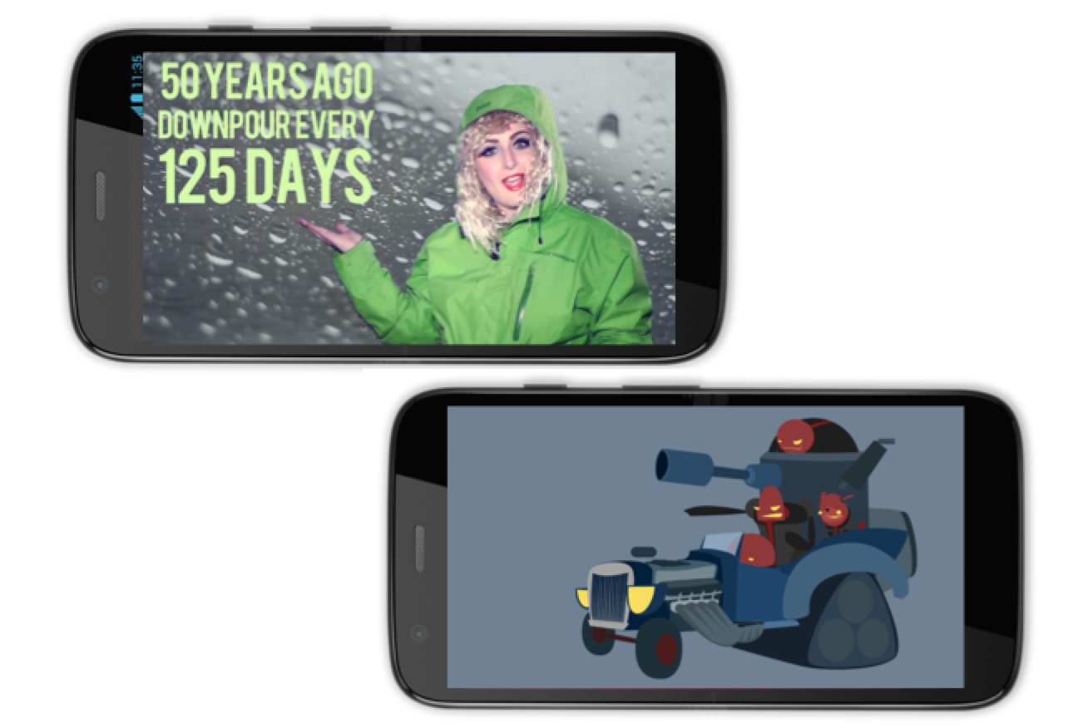
You’re Getting Warmer
http://pebblegorge.com/youre-getting-warmer/

This project mixes a real world theatrical event with a smartphone-based “geocache” game. Created by theatre company Pebble Gorge and aimed at children, the events see family groups follow a series of clues in a sequence controlled by the phone. Along the way they follow GPS linked arrows, interact with actors and real objects, solve riddles and enter clues into the phone to unlock content (including film and animation).

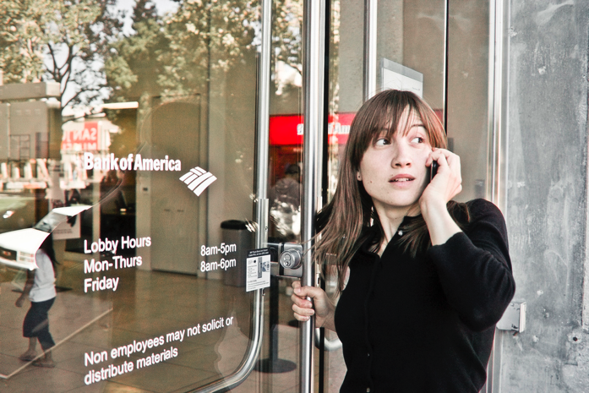

The work of Blast Theory
http://www.blasttheory.co.uk/projects

Blast Theory has a long track record of producing technology-linked real world games. Usually based in a strong narrative concept, their productions often place players into fantasy worlds within real life settings and lead them through situations and sequences to a highly charged conclusion. This arts organisation also has a track record of producing work to commission.

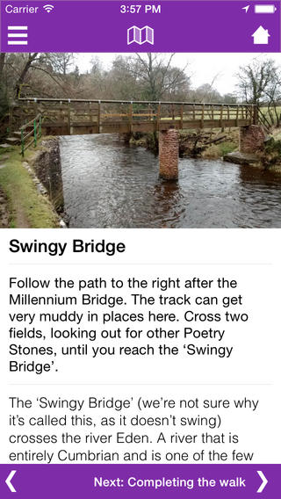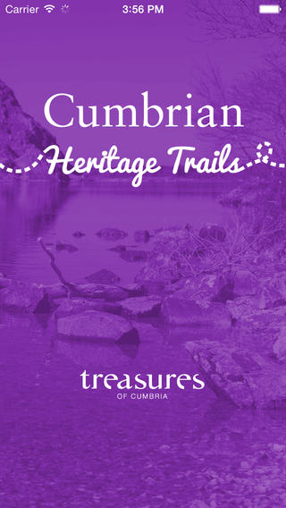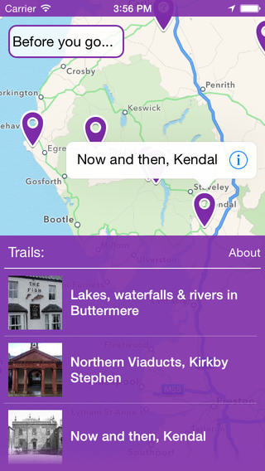

Cumbrian Heritage Trails
http://is.gd/Wgn6CT

This is a trails-based app, created (by Surface Impression) for the Treasures of Cumbria project. This represents a more “classic” approach to presenting trails through a smartphone or tablet. Each point of interest includes photos and an interpretive description, but also clear instructions on how to proceed from point to point along the trail. These instructions (and the maps that accompany them) were thoroughly user-tested to make sure they perform well in usage over the sometimes rough terrain of Cumbria.

4. Social Media
Social media was not included in the part 1 planning for the HLF application. However, we believe it is important enough to warrant discussion here. It is likely to be a significant point of contact for the audience and participants with the project.

User-generated content can be a very useful aspect for a heritage website / project, however it can be draining of project resources to monitor, moderate and manage the submissions that come in this way. By employing social media as a channel for user-generated content, resources can be deployed more efficiently, without loss of opportunity.

Aspect | Discussion/approach
Audience | All target audiences for the project can be targeted via social media, although some groups may be currently less “digital” than others, the landscape is changing rapidly. For example in recent years the 55+ age group has been the fastest growing on Facebook (whereas 13 – 24 year olds have been leaving the platform).  Some generalisations about platform and social media channel can be made  - Potential visitors to the public venues / environs – Trip Advisor / Google+  - Families – Facebook  - Events visitors – Twitter  - 16 – 29 year olds – Instagram / Pinterest / Youtube  - Family-historians – Ancestry.co.uk / Facebook  - Informal learners – Wikipedia  Note: we are including sites such as Ancestry and Wikipedia under a social media heading as they can be approached in the same way.  Estimated numbers: without advertising – 1000 to 3000 engaged people  With advertising: 10,000 to 50,000 people
Form | Engaging with social media consistently on a long-term basis can be a significant drain on resources and activities that give a sufficient return on investment for the time spent can be elusive. To help manage this, we recommend that social media activity is concentrated into “campaigns” – sustained bursts of activity centred on particular events, activities or resources. Project team members will choose one or two platforms, generated interest through a short campaign, answer responses that arise and then reallocate their time to other aspects of the project. Content creation “allies” such as the planned writer in residence or project partners will be a great help for running campaigns.  It is worth bearing in mind that some platforms, particularly Facebook are offering advertising and this is a low cost, highly targeted, way to build a social media audience as well as promote activities directly for far less investment than would be spent (of the team’s time) by attempting to achieve the same reach through the free services. We suggest setting aside a small budget of £1000 to spend on social media advertising.
Content | Campaigns should fit around the activities of the project and ideally encourage user-engagement. Targeting specific audiences as part of the campaign helps make the campaign more manageable. For example:  - Launch of an exhibition, targeting people within reasonable travelling distance of the venue  - A campaign to promote the idea of the project to disabled groups to encourage them to promote involvement to their members  Creative competitions are also a great way to encourage interaction with audience members – for example a photography competition or “design a new map”; the outcomes of which can be incorporated into the site /trails/game.  Another angle to explore is to follow a historical character day by day – using new and archive material to illustrate the “diary”. A good candidate for this would be the abolitionist Edward Rushton who set up the Liverpool School for the Indigent Blind whose life story and journeys could be explored and posted as a diary entry everyday, with links to the maps, documents and artefacts that he connects to.  Naturally all community based events, exhibitions and other activities should also be promoted through appropriate social media platforms as an ongoing process. Day to day progress of the project can be blogged through the main site, as this will be based on a platform such as Wordpress or Drupal that has built-in blogging capability. If Wordpress is used, there is a plugin called Jetpack (published by Wordpress themselves) that shares content out to the whole Wordpress network.  Using social media advertising to increase the reach of postings, events and other items is very effective. For example a promotion that costs around £50 can increase reach from under a hundred people to over 10,000.
Technical delivery | Social media platforms are third party services so do not require technical investment. Integration of social media feeds and share links into the main website will be part of the website brief.
Suppliers | Social media platforms, Accentuate team
Costs | Platforms are generally free but opportunity costs of engagement by the team should be taken into consideration.  Advertising. £1000
Timetable | Year 1: Blogging of development, setting up of platforms and building audience  Year 2: Campaigns begin  Year 3: Development of themes, engagement activities etc on social media platforms
Management | Accentuate team, digital content producer

5. Digital media within exhibitions
The exhibition design is likely to include digital media elements. Our suggestion is to maximise efficiency by reusing interactive components of the website, plus elements of work done for the game and trails. However, the exhibition versions can be “reskinned” to have a graphic design style that fits the context.

Aspect | Discussion/approach
Audience | Visitors to the physical exhibitions  Numbers: the same as projected attendance to exhibitions
Form | Cheap touch screen “all in one” computers can be used to deliver interactives / films that are served directly from the site’s infrastructure. For more economy, it is best to build the touch screen into the exhibition’s mounting rather than use a stand-alone podium.
Content | Timelines, film, place content, user generated content –aspects of the main website or game/trail content that is deemed to be useful by the Accentuate team and/or exhibition designer
Technical delivery | A customised layout of the same content, served directly from the website. Where a wifi connection is not available (or is not reliable) HTML5 caching will be used to create a local copy of the content on the machine. Display through a touch screen computer or tablet. Using a screen reader and/or switches (large physical buttons) to enhance accessibility should be considered.
Suppliers | Exhibition designer, Accentuate team, website designer
Costs | Hardware <£1000 per screen  Reversioning of content and installation: £1000 - £3000
Timetable | Year 3: Incorporation with exhibition build
Management | Accentuate team, exhibition designer

Outline Schedule (Subject to Change)

2015
Get to know 8 partner venues - June-November 2015 (6 months)
Create project team roles for recruitment - June-August (3 months)
Create briefs for brand designers, freelancers and development agencies - June-August (3 months)
Brand design for project created - August-September (2 months)
Recruit digital content editor - August
Recruit access consultant/user tester - August
Commission web developers August-September (2 months)
Development of website begins - 12 months (10/15-10/16)
Plot out content plan - October-November (2 months)
Holding pages for website released - November
Social media accounts selected and launched - December
Recruit film-maker - November- December (2 months)
Recruit creative facilitator - December

2016
Game, film and tour element creation begins
Commission games/trail developer - January-Feb (2 months)
Content for 8 sites rounded up and selected March-May (3 months)
Oral history content capture Jan-Dec 2016 (12 months)
Audio tours and trails completed and released (venue by venue) June-November 2016 (6 months)
Full website launch October 2016
Main access/user testing undertaken
User testing (website, games, trails) August/September (2 months)
Game/trails and film element creation begins March-August (over 6 months):
- Games/trails workshops run March-June (over 4 months)
- Films workshops run March-June (in parallel, over 4 months)
Games/trails and films content assessed and created July (1 month)

2017
Game, film and tour element creation continues
Website content development and expansion
Games/trails completed and released (perhaps venue by venue x 4) Jan-April
Website content development and expansion (ongoing as any new content created)
Work with exhibition developers for design consistency, to share digital assets and to integrate interactives into the overall exhibition Jan-April (4 months)
Repurpose games/trails and website content to create touch screen content for exhibition May-July (3 months)
Access user testing of exhibition and interactives August-September (2 months)
Exhibition launched and run across 2-3 venues Dec 2017-June 2018 (7 months)
Promote events and exhibition on social media

2018
Game launched by Easter 2018
The launch of the games/trails could be held back to ensure they coincide with the travelling exhibition and with community events that are being run etc.

